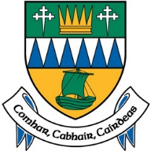

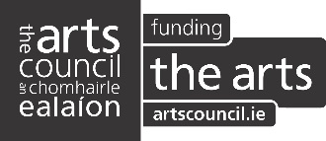

Comhairle Contae Chiarraí
Kerry County Council

_____________________________________________________________________
KERRY VISUAL ARTISTS’ SHOWCASE (KVAS) 2019

Name of Artist
Address
Email
Mobile
Website

1. Please provide a statement about your work detailing your current arts practice and the media involved (max 300 words)

2.Please outline your future plans including projects, exhibitions etc. (max 150 words)

3.Please describe how this opportunity will help to develop your career (Max 200 words)

4.Please give details of any awards or recognition you have received over the last two years:
5.Please give the names and addresses of two visual arts professionals from whom
references may be requested (not relatives):

Checklist
C.V. an Ealaíontóra |  | Artists C.V.
Samplaí oibre an Ealaíontóra |  | 10 images of work including works available for exhibition
 |  | Corresponding list of images with titles, dimensions, medium, etc.
 |  | Installation specification for work, if applicable
Return of enclosed material (tick as appropriate)
Baileoidh mé an t-ábhar |  | I will collect the material
Ní mian liom an t-ábhar a fháil ar ais |  | I do not wish to have the material returned
Tá stampaí/clúdach le stampa iniata |  | Stamps/stamped addressed envelope enclosed

CRITERIA AND ELIGIBILITY
- Artists working in all media are encouraged to apply. Selection may be for 2019 or 2020.
- Applicants must complete all sections of the form.
- Application must be submitted before the stated deadline.
- Application must be fully completed and signed.
- The opportunity is open to professionally qualified* artists originally from, or resident (for at least 2 years) in, County Kerry.
- Artists must not be enrolled in undergraduate courses.
- Works submitted for consideration must have been created in the past 18 months.
- Due to the nature of the exhibition space the following size restrictions apply:
2D = 5’x5’ unframed & 3’x 3’ framed with glass.
All 3D work over 3’ x 3’ x 3’ will be subject to weight restrictions, please give weight and size of work on your Image List Sheet where applicable.
- No hard-copy material will be accepted (catalogues, invitations, artist books, etc.).
- Please label each Jpeg image with the following details:
Artist's Name_Title_Medium_Dimensions_Year, for example: JohnSmith_BlueLandscape_OilOnWoodenPanel_43x30cms_2013
- Please label each audio or video work with your name and contact number, work title, and duration, and include an additional image of same as displayed artwork.
*Hold a relevant undergraduate degree in a Fine Art discipline, be a member of Visual Artists Ireland, or have a proven track record.

Please email completed application for and support material including C.V. no later than
4.00pm Friday 8th March 2019 to arts@kerrycoco.ie Please mark the subject line in your email as Submission-Kerry Visual Artists’ Showcase.

Signed: ____________________________________

Date: ____________________________________

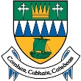
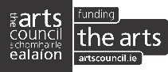
This initiative is jointly supported by Kerry County Council and the Arts Council.

