Kerry County Council
Expression of Interest for Inclusion in the
Town & Village Renewal Scheme 2020
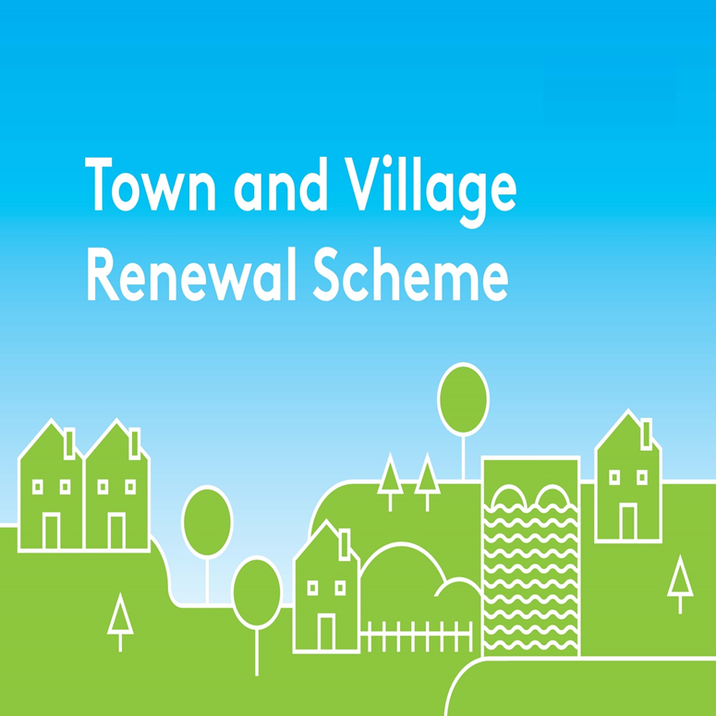
Completed Expression of Interest Forms, along with any necessary supporting documentation, must be returned to:

Community Department, Kerry County Council, County Buildings, Rathass, Tralee, Co. Kerry or email to community@kerrycoco.ie

The closing date for receipt of Expressions of Interest is 5 p.m. on Friday 10th July, 2020
(The deadline is set to allow all applications to be assessed in advance of the Local Authority submitting final applications to the Department of Rural and Community Development by 28th August, 2020).

Applications received after the deadline will be ineligible for consideration under this Call for Proposals

Town & Village Renewal Scheme 2020

*denotes required field

Town/Village covered:

Please indicate which category of funding is being applied for:*

Category 1 Category 2

Towns/Villages with Towns/Villages with

Population of 5,000 Population of

or less 5,001-10,000

Amount of Funding Requested:

Applicant Group:

Applicant Contact Name:

Applicant Contact Address:

Applicant Telephone Number:

Applicant Mobile Number:

Applicant Email Address:

- Project overview
1.1 Location of the project: *
Where is the project located? Provide the name of the town(s), village(s) or area(s) which will be involved in, or benefit from, the project.

1.2 Anticipated commencement and completion dates: *
Proposed Start Date:
Proposed completion date:

1.3 Summary of the Proposal: * Please submit additional information on separate sheet if required
1.4 Link to other statutory or strategic plans:
Outline how the proposal links with, and contributes to, County Development Plan(s), Local Economic and Community Plan(s), Regional Spatial and Economic Strategies, or other local or regional development plans/strategies.

1.5 Has funding for this project ever been sought from other sources? * Yes No
(If "YES" yes please specify from what source and if funding was provided)

1.6 Who are the specific project stakeholders/community partners in this project? (Chamber of Commerce, Community group, etc.): *

1.7 If seeking funding of between €100,000 and €200,000, please detail the particular economic case for this level of funding.

1.8 What is the objective of the proposed project and how will the intended outcomes be measured? (Please identify any metrics or benchmarks that will be applied).

- Financial overview
2.1 Provide details of the total cost of the proposal and the grant aid being sought: *
Note: Only expenditure incurred after the approval date of a project will be eligible for funding.
Total cost
Grant aid sought
Match funding

2.2 Breakdown of total project cost:
Item | Cost

2.3 Details of match funding: *
Source of match funding: | Total Amount:

Has match funding for this project been confirmed? * | Yes | No
If "YES" please provide supporting documentary evidence as an addendum to this Application Form

2.4 Permissions*
 | Yes | No | N/A
Have all necessary planning permissions and consents been obtained for the project and any applicable heritage or environmental assessments completed?
If "YES" please provide supporting documentary evidence as an addendum to this Application Form
If "NO", please detail plans in this regard

 | Yes | No | N/A
If the project involves works on buildings or lands, does the applicant/partners own the premises where upgrade/refurbishment/improvements are proposed?
If "NO", please detail plans to ensure permissions are obtained

DECLARATION
I hereby confirm that I have read and understand this document. I request that consideration be given in support of the project as outlined above.

Signature __________________________________________________

Position __________________________________________________

Organisation __________________________________________________

Date __________________________________________________

