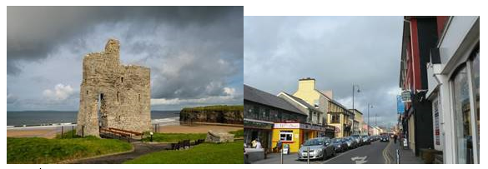
Kerry County Council
Pilot Shopfront Enhancement Grant Scheme - ballybunion
Our Rural Future – funded by the Department of Rural & community Development (DRCD)

Guidelines and Application Form 2021

Please read the Terms and Conditions attached to this scheme prior to completing the application form.

All questions must be answered

Closing date for receipt of applications is

7th September 2021

N.B: Applications will be deemed invalid if not accompanied by the information requested in these Guidelines

Works must not commence prior to receipt of written approval from Kerry County Council

Purpose

Kerry County Council are pleased to announce the Pilot Shopfront Enhancement Scheme. The objective of this scheme is to enhance the streetscape environment of Ballybunion Town Centre by encouraging and supporting business owners to improve their individual shopfronts. It is intended that the scheme will result in a more attractive environment that residents, visitors, shoppers and businesses can enjoy. It is also envisaged that this scheme will assist in promoting Ballybunion as an attractive place for social and business interaction, thereby increasing the vitality and viability of the town, with positive beneﬁts for all.

Overview

Shopfronts are an integral part of our streetscapes and well - maintained shopfronts of suitable design are essential in providing an attractive and vibrant place in which to do business, work, shop and carry out leisure and entertainment activities.
In recognition and promotion of this, Kerry County Council has developed a Pilot Shopfront Enhancement Grant Scheme for Ballybunion Town Centre, see map for details:
- Supporting the vitality and viability of Town Centres thereby contributing to a high standard of design.

- Supporting competitiveness and choice in the retail sector commensurate with promoting the vitality and viability of the Town Centre.

- Contributing to the enhancement of the aesthetics and character for the overall betterment of the town through a collective and coherent approach.

- Encouraging best practice approaches to shopfront maintenance and presentation.

- This scheme will provide ﬁnancial supports in 2021, subject to the Terms and Conditions of the Scheme.

Qualifying Locations for Pilot Scheme

Funding for this initiative which was secured through the Department for Rural and Community Development under the Town and Village Renewal Scheme is limited so it is intended that the scheme will be piloted in the following Ballybunion Town Centre locations. If the initiative is successful, consideration can be given at a later stage to rollout of the Scheme in other locations, subject to a suitable funding stream being identified:

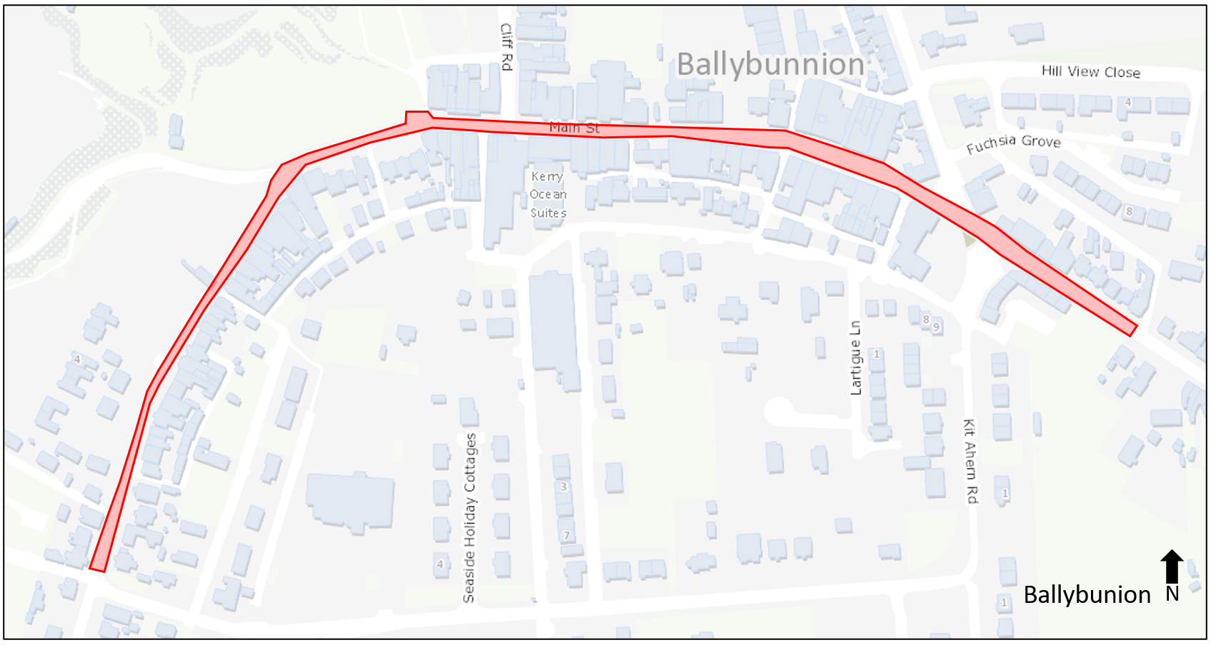

Guidance Documents on Policy and Standards

Shopfronts are a very important element of the streetscape. Therefore, they should be of a high standard of design and reflect the architecture of the original building and of the surrounding area.
It is the policy of the Council to preserve and retain traditional shopfronts that contribute to the character of Kerry. The need to change old shopfronts whether protected or not will be closely questioned. Preference should be given to refurbishment rather than replacement. Regular inspection and maintenance is essential to avoid serious defects and decay.
Kerry County Council seeks to encourage retail innovation, creativity, vitality and recognises the role shopfronts, signs and advertising can have on the character of a street.
Any proposed shopfront enhancements should be considered in the context of Kerry County Council’s Shopfront Design Guidelines which sets out a guide on best practice in relation to shopfronts - https://www.kerrycoco.ie/planning/planning-policy/shopfront-guidelines/.

Terms & Conditions
Timelines
Kerry County Council is seeking applications from property owners in the above Towns by 5pm 7th September 2021.

Applications will be assessed and successful applicants will be notified by September 20th 2021.

Applicants must complete the works as per letter of offer and submit invoices, evidence of payment and photographs of completed works NO LATER than November 5th 2021.

Grant Rates
The grant scheme is at 70% grant rate in the case of an individual property or 80% where there are 3 or more adjacent properties.

Eligible Works
Kerry County Council schemes allows for the following eligible works:
- Replacement of existing shopfront with traditional painted wooden shopfront OR Contemporary Design (max €4,000 grant/building)

- Replacement of signage with traditional wooden fascia with wooden/hand painted lettering OR Contemporary design; Careful illumination and lighting of architectural features of buildings; Improvements to shopfront window displays and staging. (max €4,000 grant/building)

- Decluttering of Shop-fronts, e.g. removal of redundant wiring/poles/signs (max €2,000 grant/building)

- Painting of building/shopfront in Local Authority pre-agreed colours (max €1,500 grant/building)

- Green enhancement of entrances/terraces with planting (max €500)

- Maximum overall grant for any one building is €8,000

Procurement
- 2 written quotations for any works/services under €3,000.
- 3 written quotations for any works/services above €3,000
- Quotations must be on headed paper of supplier with contact details, VAT registration and date and addressed to the Applicant.

Photographs
- Photograph must be submitted of building with application form.

- Applications may not be considered where there are local taxes or charges due to the Council. However, consideration will be given in such instance where there is an agreed payment plan in place that is being adhered to.
- Applicants may submit an application for the grant in advance of obtaining planning permission (if required). However, grant approval will be subject to the applicant having obtained planning permission. The Planning Reference No. should be quoted on the grant application, where applicable.
- Applications will be accepted from either the landlord or by the lessee with the owner’s written consent. However, only one application per building will be accepted.
- Works must not commence prior to receipt of written approval from the Council.
- Where a contractor is appointed it shall be the responsibility of the successful applicant to ensure that all necessary consents are obtained and all relevant legislation and codes of practice, in particular those related to Health & Safety and Planning which apply to such work and / or approved schemes, are complied with.

Will I require Planning Permission?

- Applicants may submit an application for the grant in advance of obtaining planning permission (if required). However, grant approval will be subject to the applicant having obtained planning permission. The Planning Reference No. should be quoted on the grant application, where applicable.
- Please note that material alterations to a Protected Structure will require Planning Permission.
- Applicants are advised to contact Kerry County Council in advance of the making of any application for funding to discuss individual proposals. Guidance will be provided by a Planning Officer in respect of whether the proposed works put forward by prospective applicants for funding require the making of a planning application or whether the works proposed are exempt from planning permission.
- Nothing in the agreement or negotiation of the grant will affect the Council’s decision with regard to planning permission. The Council accepts no responsibility should a business receive a Grant of Offer letter or subsequent grant payment, which become subject to Planning Enforcement proceedings relating to improvements for which monies are issued. In such circumstances any offer of funding will be withdrawn and applicants will be required to reimburse any grant claimed and to comply fully with statutory planning requirements.

The contact details for the Planning Section are follows:
Kerry County Council, Rathass, Tralee, Co. Kerry
Telephone – 066 7183582
Email: plan@kerrycoco.ie

Timeline
In the event that planning permission is required for the works proposed, please note that this is a separate process to this Grant Application Scheme and the associated timelines in the processing of a planning application apply.
Planning permission if required, must be in place before approval can issue for the enhancement grant.

How to Apply for a Grant

- The attached application form when completed and signed should be submitted along with all required documentation to:
Shopfront Enhancement Scheme Administrator, Local Enterprise Office, County Buildings, Tralee, County Kerry
Email: Enterprise@kerrycoco.ie

The closing date for receipt of fully completed applications is
5pm 7th September 2021
- Applications may be made by the owner of the premises or by the lessee with the owner’s written consent.
- Applications should clearly identify each element of the works proposed.
- The completed Application Form must be accompanied by a description of the proposed works to include:
- Photographs of existing shopfront (prior to work being carried out).
- Photographs of an example of what the new shopfront will look like.
- Map identifying the location of the shop (a Google Map will suffice).
- Record of Protected Structures number, where relevant.
- Details of proposed changes (e.g. Drawings of new Shopfront or new Signage).
- Indication of material type and/or colour scheme to be used.
- The applicant should also specify if they require the advice of the Colour Consultant Company who have agreed to sponsor an appropriate colour design solution for those property owners who wish to repaint their buildings through this scheme.
  - Two/Three written quotations (see guidelines above) for the proposed works from registered builder(s)/contractor(s).
  - The grant offer will be made based on the lowest quote submitted for the works proposed but the Council may also have regard to specialist conservation/repair works for protected structures. The applicant may choose either supplier/contractor to complete the works. However, the grant payment will not exceed the amount speciﬁed in the grant letter offer.
Note:
A site visit may be arranged with the applicant to discuss the application and if necessary facilitate the submission of further information in support of the application.

Assessment Criteria

The following will be considered in the assessment of applications:
- The quality and suitability of the proposed changes to the shop front / building façade.
- Impact on the immediate area of the street.

The Budget in 2021 for this scheme is limited and applications for funding will be assessed by an Adjudication Panel appointed by the Council, whose decision shall be ﬁnal.

If the scheme is oversubscribed the applicants eligible to continue in the application process will be selected by what is considered by Kerry County Council to deliver the greatest impact in terms of visual appearance/streetscape enhancement and the economic impact it could have in the area.
- Preference will be given to applications for clusters, where a number of adjacent properties make simultaneous applications. (A cluster application is a set of business owners where shops are located in close proximity to each other. Tenants and property owners are encouraged to work together in order to bring forward proposals that will provide a significant visual impact.
- Works must not commence prior to receipt of written approval from Kerry County Council
- Promoter should demonstrate ability to deliver project completion and submission of claim by November 5th, 2021.
- The scheme may be the subject of review and amendment at any time by the Council.
- The Council reserves the right to publish photographs of improved shop fronts in promotional material associated with the scheme and its purpose.

If you require further information or have any enquiries please contact:
Listowel Municipal District, Áras an Phiarsaigh, Charles Street, Listowel, Co Kerry
Telephone: (068) 21245
Email: listowelmd@kerrycoco.ie or edu@kerrycoco.ie

Grant Drawdown

Payment will only be made following completion of appropriate, approved works.
- Upon completion of works, the applicant must submit evidence of paid contractor invoices, together with photos of the completed shopfront to Kerry County Council.
- All payments must be made through the applicant’s bank account. Cash payments will not be eligible for grant aid. Bank Statements will be required as evidence of payment.
- An inspection may be undertaken to ensure compliance with the agreed work schedule.
- If the inspection/works are satisfactory, Kerry County Council will then pay the applicant.
- Applicants must complete the works as per letter of offer and submit invoices, evidence of payment and photographs of completed works NO LATER than November 5th 2021.
- Tax Reference Number & Access Number of the proposed builder/contractor and the business owner must be provided.

Note:

Grants are awarded entirely at the discretion of the Council. If the application is successful, Kerry County Council will send a Grant Offer letter, conﬁrming the grant offered, in accordance with the guidelines.
Any alterations to design and/or materials must be agreed in advance and recorded on the work schedule.
No grant will be paid to any project where changes are made that have not been agreed with Kerry County Council.
Works not completed in accordance with sound conservation methodology and practice will not be grant-aided.

Shopfront Enhancement Grant Scheme – Ballybunion Town Centre
Application Form
Applicant Name & Contact Details
Applicant Name:
Correspondence Address:
Property Address:
Property Eircode:
Business Name (currently operating from the premises):
Contact Phone No: | Landline: | Mobile:
Contact Email:
Interest in Property (owner or tenant*):
*Please also include a letter of consent from the owner.
If you are a tenant, please state remaining No. of Years on lease:

Details of Works Proposed
Type of Works Proposed (see Note below)

Note 1: Please include supplementary information with exact details of works proposed including a copy of relevant plans, designs and specifications for proposed works. Two/three quotation (check guidelines) are required and all applications must include colour photographs of the existing property.
Note 2: Works commence prior to grant approval will not be funded.
Details of Works Proposed
Is this a single application or part of a cluster application?  (A cluster application is a set of individual applications of business owners whose shops are located in close proximity to each other) | Tick appropriate box  Single:  Cluster:
Customer Rate No:  (Seven digit number on Rate Demand – starting with “260”)  Rates must be paid in full or a rates payment plan is agreed | Rates Customer Account No:
If the works proposed include painting of the shopfront, do you require the advice of a colour consultant? | Tick appropriate box  Yes  No  N/A

Timelines for the undertaking and completion of works
Estimated Start Date:

Estimated Completion Date:

Have the necessary planning consents been sought, if required
Planning Permission (Please supply planning reference number) | Tick appropriate box  Yes  No  N/A

Costings | Cost of Works
Total Cost of Works  (Please include at least 2/3 quotations for these works) depending on scale | Quotation 1  Quotation 2  Quotation 3
How much grant funding are you seeking?
See Guidelines for Eligible Grants Sums
Declaration
I declare that I have read, fully understand, and agree with the terms and conditions, assessment criteria and grant drawdown terms of the scheme and I confirm that, where required, I have applied for any necessary consents or permissions, statutory or otherwise.
Signed
Date

Attached application to be completed and returned to: Shopfront Enhancement Scheme Administrator, Local Enterprise Office, County Buildings, Tralee, County Kerry

Email: Enterprise@kerrycoco.ie

Deadline: 5pm 7th September 2021

Checklist - Please ensure that the following documentation is included in the application:
Declaration
- Fully completed application form (all answers filled in).
- Letter of Consent from Property Owner (if property is rented or leased).
- Copy of relevant plans, designs and specifications for proposed works.
- Photographs of existing shopfront (prior to work being carried out).
- Photographs of an example of what the new shopfront will look like.
- Two/Three written quotations for the proposed works from registered builder(s)/contractor(s).
- Record of Protected Structures number, where relevant.
- Planning reference No. (if applicable)

ADVISORY NOTE: Planning permission may be required for some works and it is the applicant’s responsibility to ensure the requirements for planning permission have been met. Such requirements will not be dealt with through the application process for this scheme.

