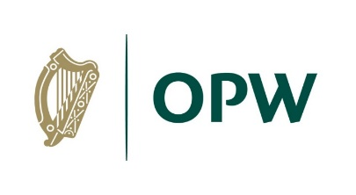

**Public Information Notice**

**Tralee Flood Relief Scheme**

**Public Consultation #1**

**Venue: Online Virtual Consultation Room**

**Date: Commencing Friday 26th November 2021**

**Time: The Virtual Consultation Room will be available until Thursday 23rd December 2021**

Kerry County Council in conjunction with the OPW are progressing the implementation of the Tralee Environs Flood Relief Scheme.

Interested members of the public are invited to log in to the virtual consultation event on the project website at: [www.floodinfo.ie/traleefrs](https://eur03.safelinks.protection.outlook.com/?url=http%3A%2F%2Fwww.floodinfo.ie%2Ftraleefrs&data=04%7C01%7CEric.Wong%40rpsgroup.com%7Cd982d254d9734b60a56508d9a9acfdc7%7C49833998a8f1424bbf845d50f102d530%7C0%7C0%7C637727382729153453%7CUnknown%7CTWFpbGZsb3d8eyJWIjoiMC4wLjAwMDAiLCJQIjoiV2luMzIiLCJBTiI6Ik1haWwiLCJXVCI6Mn0%3D%7C3000&sdata=wZ0gGP36iJFPIVuo6jw3h1eX7Qb5M4BaontN2LTzPrU%3D&reserved=0)

The purpose of this early-stage consultation event is to give interested individuals an overview of the project, to offer the opportunity to engage with the project team and tell their experiences of flooding in Tralee and offer views on how the scheme should progress.

The virtual consultation room includes information on the project and currently identified environmental constraints that may influence the scheme design.

A Project Newsletter is available for viewing and/or download and a Feedback Form is also available for completion.

Due to current Covid-19 risks this Public Consultation Day event will take place in an online forum via the project website. However, if you are interested in an in-person consultation, please contact the project team by email at [traleefrs@rpsgroup.com](mailto:traleefrs@rpsgroup.com) or by phone at (021) 466-5900 and this will be arranged over the coming weeks.