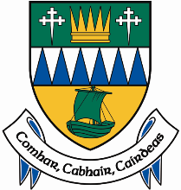
Comhairle Contae Chiarraí
Kerry County Council

Rates Revaluation 2021 deferred to 2023
Advisory Note re Written Correspondence to issue to Ratepayers
From the Valuation Office the week of the 7th of March 2022

We wish to advise that the Minister for Housing, Local Government and Heritage has agreed with the Commissioner of Valuation that the Commissioner will defer the revaluation of rateable properties in the following local authority areas until 2023:
Clare County Council, Donegal County Council, Dún Laoghaire-Rathdown County Council, Galway City Council, Galway County Council, Kerry County Council and Mayo County Council.
New valuations arising from the revaluation of these local authorities will now be finalised in October 2023 and become effective for rates purposes from 2024 onwards.
The Valuation Office will write to all ratepayers in the local authority areas above the week of the 7th of March 2022 to notify them of the changed timelines.
The revaluations are being deferred so that the impact of Covid 19 on the commercial property market in the seven local authority areas can be assessed and reflected in the new valuations.
The new valuations will be published in October 2023 and will become effective for rates purposes from 2024 onwards.

