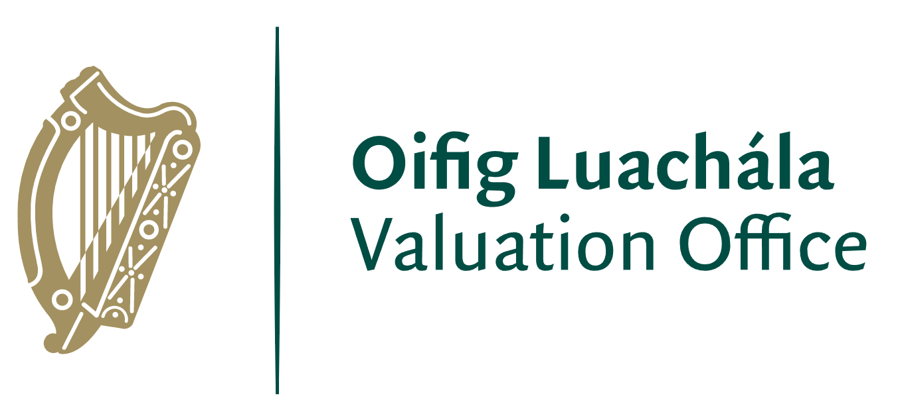

Walk in Clinics –Kerry County Council

Date | Location Address | Time
Monday 3rd October 2022 | Killarney Municipal Area Office, Main Street, V93 KH5V - Chamber | 10am to 4.30pm
Monday 3rd October 2022 | Adult Education Centre, Dromtacker, Tralee, V92 HK52 | 10am to 4.30pm
Tuesday 4th October 2022 | Killarney Municipal Area Office, Main Street, V93 KH5V | 9.30 am to 4.30pm
Tuesday 4th October 2022 | Adult Education Centre, Dromtacker, Tralee, V92 HK52 | 9.30 am to 4.30pm
Wednesday 5th October 2022 | Cahersiveen Library, New Market Street, Carhan Lower, V23 H523 Meeting Room | 9.30 am to 4.30pm
Wednesday 5th October 2022 | Listowel - Kerry Writers Museum, 24 The Square, Listowel, V31 RD93 | 9.30 am to 4.30pm
Thursday 6th October 2022 | Dingle Creativity & Innovation Hub, Cooleen Business Park, Dingle, V92 P9NX | 9.30 am to 4.30pm
Thursday 6th October 2022 | Kenmare Adult Education Centre, Bell Height, V93 K5CV | 9.30 am to 4.30pm
Friday 7th October 2022 | Castleisland- An Riocht, Crageens, V92XV82 | 9.30am to 4.00pm
Friday 7th October 2022 | Killorglin Area Services Office, Library Place, Iveragh Road, V93 E221 | 9.30am to 4.00pm

