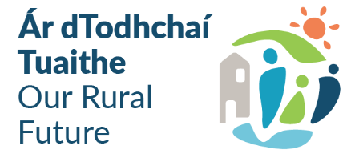
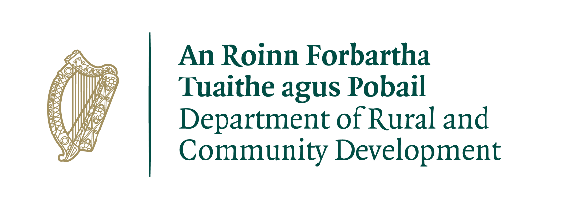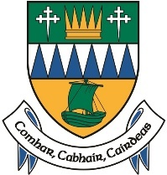

Community Recognition Fund 2024
Funding Proposal Form – Measure 2
Closing Date: Wednesday 31st July 2024 at 5:00 pm
Measure 2 is to fund transformative capital projects of scale that will revitalise and enhance the economic and social environment of these areas. Projects under this measure will range in value from over €200,000 up to a maximum of €500,000.
Note: Business Case at end of this Proposal Form must be completed for all Measure 2 projects
Applicant Group/Organisation
Applicant Contact Name (liaison for entire funding proposal)
Applicant Address
Applicant Email address
Applicant mobile number
Applicant landline number

Requirement for funding
Detail any gaps in community facilities/infrastructure.
Village/Town Name
Number of new arrivals
Amount of Funding requested | €

Outline the steps taken to ensure that the proposed project has been identified in consultation with your community.

Who are the specific stakeholders/community partners in this project? (e.g. Chamber of Commerce, Community Group, etc.)

Outline how the proposed project will deliver tangible benefits to the community.

Has any element of this proposal previously been approved under a Government Department scheme?
If so, please outline.

Project Details
Village/Town Name | Project Elements | Total Costs | Detail position re. the required consents/ permissions /ownership | Estimated Completion Date
 | Please list all elements of the proposed project. |  | Appropriate assessment, planning, land ownership etc., if not in place please specify and give the estimated timeline | Approved projects will commence in 2025 and must be completed during 2026 and at least 50% of the proposed project costs must be expended in 2025
Total Project Costs |  | €
Local Community Contribution |  | €
Overall Grant Amount Sought |  | €

When preparing your application, please refer to the scheme guidelines available on Kerry County Council website.

Community Recognition Fund (CRF) 2024
Business Case template which must be completed for each Project Over €200,000

Project name
City, town or village name
Summary of the proposal
Project rationale & rationale for selecting this location
Outline the community engagement and consultation
Outline the capacity of the group to deliver the project as outlined
Include details of the track record of project partners and experience of delivering similar projects
Identified needs this project will aim to address

Use of Data
Kerry County Council will use the information on this form to process the application. Kerry County Council may seek further information to clarify aspects of the project proposal. Kerry County Council may share the form with other Government Departments for assessment purposes.

The Applicant and Kerry County Council are subject to the data protection and privacy laws of Ireland and the EU, in particular the Data Protection Act 2018 and Regulation (EU) 2016/679, known as the EU General Data Protection Regulation (“GDPR”). Any personal information you provide as part of the application process will be obtained and processed in compliance with Data Protection legislation.

Kerry County Council retains the right to disclose for a request under the Freedom of Information Act 2014 or otherwise in connection with the funded project(s) –
- any information supplied by the Applicant to Kerry County Council, and
- any relevant data gathered by Kerry County Council in administering grant aid to the project, except where the information is considered personal or commercially sensitive.

Declaration by Applicant
I confirm that I have read and understood this document and declare that the particulars supplied in this funding proposal are true and correct and that –
- The costings are accurate and reasonable.
- All necessary permissions are in place, e.g. planning consent etc.
- All relevant ecological survey work (if applicable) has been undertaken or will be undertaken, e.g. Appropriate Assessment screening.
- There is evidence of ownership (if applicable) or landowner’s consent or in the case of a lease, evidence that a lease is in place for a term not less than 15 years.
- The project will comply with Public Procurement Guidelines.
- The project conforms to the LECP and other local or regional plans.
- No government funding has been allocated for the same works from any other sources.

I acknowledge the information regarding the use of data set out above and give consent to Kerry County Council for the sharing of all information, personal or otherwise, contained in this funding proposal and any attachments accompanying it, in accordance with the uses of the data and information provided above.

DECLARATION

I hereby confirm that I have read and understand this document. I request that consideration be given in support of the project as outlined above.

Signature __________________________________________________

Name in Block Capitals______________________________________

Position___________________________________________________

Date__________________________________________________

