Public Spending Code
Quality Assurance Report for 2024
Kerry County Council

To be submitted to
National Oversight and Audit Commission (NOAC)

Certificate

This Annual Quality Assurance Report sets out Kerry County Council’s approach to completing the Quality Assurance requirements as set out in the Public Spending Code. It is based on financial, organisational and performance related information available across the various directorates of the Council.

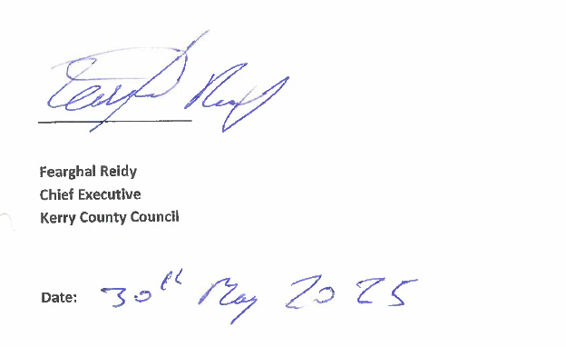

Contents

Introduction 4
Requirements of the Quality Assurance Aspect of the Public Spending Code 4
STEP 1 – Project Inventory 5
STEP 2 - Summary of Procurements in excess of €10m 6
STEP 3 - Checklists 6
Findings on Completion of Checklists 6
STEP 4 - In-Depth review of a sample number of projects 7
Internal Audit In-Depth Checks 7
Conclusion 11
Appendix A – Inventory of Projects and Programmes Over €0.5m - 2024 12
Appendix B – Checklists of Compliance 13
Checklist 1 – General Obligations not specific to Individual Projects or Programmes
Checklist 2 – Capital Expenditure Being Considered
Checklist 3 – Current Expenditure Being Considered
Checklist 4 – Incurring Capital Expenditure
Checklist 5 – Incurring Current Expenditure
Checklist 6 – Capital Expenditure Completed
Checklist 7 – Current Expenditure at end of planned timeframe or discontinued
Appendix C – Quality Assurance – In-Depth Check Templates – 2024 Projects 21

Introduction

Kerry County Council has completed the Quality Assurance (QA) requirements as set out in the Public Spending Code for the 2024 financial year. The purpose of this report is to present the results of each of the Five Steps in the QA exercise and to report on compliance with the requirements of the Public Spending Code.
The Public Spending Code was written specifically using terminology familiar to Government Departments. In order to inform the QA exercise for the Local Government Sector a Guidance Note (Version 4) was developed for the sector to provide interpretation from a Local Government perspective.

Requirements of the Quality Assurance Aspect of the Public Spending Code

The Quality Assurance obligation involves a 5-step process outlined below:
- Step 1 – Compilation of an inventory of projects/programmes at the different stages of the Project Life Cycle that have a total Project Life Cost of €500k or more.

- Step 2 - Publishing summary information on Kerry County Council’s website of all procurements in excess of €10m; related to projects in progress or completed in the year under review. (The PSC originally required projects in excess of €2m to be published under this requirement but is now revised to €10m) A new project may become a “project in progress” during the year under review if the procurement process is completed and a contract is signed.

- Step 3 - Completing the 7 checklists contained in the PSC. Only 1 of each checklist per Local Authority is required. Checklists are not required for each project/programme.

- Step 4 - Carrying out a more in-depth check on a small number of selected projects/programmes based on criteria established within the Public Spending Code.

- Step 5 - Completing a short summary report for the National Oversight and Audit Commission (NOAC). The report, which will be generated as a matter of course through compliance with steps 1-4 set out above.

STEP 1 – Project Inventory
The project inventory presents a list of all projects/programmes with activity in 2024 and which have a total project life cost of €500,000 or more. The inventory is presented showing the 3 stages as set out in the table below which also outlines the Expenditure Category/Band relevant for inclusion in each stage:

Project/Programme Stage |  | Category/Band
1 | Expenditure being considered | Current Expenditure programme - Increases over €0.5m
1 | Expenditure being considered | Capital Grant Schemes > €0.5m  Capital Projects between €0.5m - €5m  Capital Projects between €5m - €20m  Capital Projects over €20m
2 | Expenditure being incurred | Current Expenditure > €0.5m
2 | Expenditure being incurred | Capital Grant Schemes > €0.5m  Capital Projects > €0.5m
3 | Expenditure that has recently ended | Current Expenditure > €0.5m
3 | Expenditure that has recently ended | Capital Grant Schemes > €0.5m  Capital Projects > €0.5m

The Project inventory, set out in the format described above, is included in Appendix A. The Inventory contains 286 Projects under the three stages and comprise of a total value of €2,181.752m. The following tables provide an overview of the number of projects under each Project/Programme stage and under each of the categories/bands in each of these stages. It also provides an overview of the Project Costs under each category.
 | Current Expenditure | Capital Grant Schemes | Capital Projects | Capital Projects |  |  | Totals
Project Values €m | > €0.5m | > €0.5m | > €0.5m | €0.5m - €5m | €5m - €20m | Over €20m
Expenditure Being Considered | 17.929 | - | 499.532 | 86.749 | 137.862 | 274.921 | 517.461
Expenditure Being Incurred | 228.090 | - | 1,335.063 | 157.271 | 286.130 | 891.662 | 1,563.153
Expenditure Recently Ended | - | - | 101.138 | 46.293 | 54.845 | - | 101.138
Totals | 246.019 | - | 1,935.733 | 290.313 | 478.837 | 1,166.583 | 2,181.752

 | Current Expenditure | Capital Grant Schemes | Capital Projects | Capital Projects |  |  | Totals
Project Numbers | > €0.5m | > €0.5m | > €0.5m | €0.5m - €5m | €5m - €20m | Over €20m
Expenditure Being Considered | 9 | - | 73 | 54 | 13 | 6 | 82
Expenditure Being Incurred | 55 | - | 117 | 78 | 29 | 10 | 172
Expenditure Recently Ended | - | - | 32 | 26 | 6 | - | 32
Totals | 64 | - | 222 | 158 | 48 | 16 | 286

STEP 2 - Summary of Procurements in excess of €10m
In compliance with the requirement to publish all procurements in excess of €10m, both our Public Spending Code Quality Assurance report for 2024 and details of any procurement in excess of €10m are published on our website and can be found using the following link - https://www.kerrycoco.ie/finance/financial-documents/. Details of the following procurements and progress on resultant contracts are available on the council’s website.
- Lohercannon Housing Construction Project
- Ballybeg Dingle Housing Construction Project
- N69 Listowel By-Pass

STEP 3 - Checklists
Step 3 of the Quality Assurance procedure for the Public Spending Code involves the compilation of checklists. There are 7 checklists in all. Checklist 1 captures general information while Checklists 2, 4 and 6 are related to Capital Projects and checklists 3, 5 and 7 are Revenue Expenditure related.
The Checklists are informed by the Project Inventory and the following table outlines the approach taken for the completion of the Checklists.
Checklist Completion aligned with Project Inventory
Expenditure Type | Checklist to be completed
General Obligations | General Obligations - Checklist 1
A. Expenditure being considered | Capital Projects/Programmes - Checklist 2  Current Expenditure – Checklist 3
- Expenditure being incurred | Capital Projects/Programmes – Checklist 4  Current Expenditure – Checklist 5
- Expenditure that has recently ended | Capital Projects/Programmes – Checklist 6  Current Expenditure – Checklist 7

All checklists, as outlined below, have been completed and can be found in Appendix B of this document.

- General Obligations Not Specific to Individual Projects/Programmes.
- Capital Projects or Capital Grant Schemes Being Considered.
- Current Expenditure Being Considered
- Capital Expenditure Being Incurred
- Current Expenditure Being Incurred
- Capital Expenditure Completed
- Current Expenditure Completed

Findings on Completion of Checklists

While the responses included in the checklists indicate a satisfactory level of compliance, there are indications that there is room for improvement in certain aspects of the requirements. However, no specific serious issues/concerns were evident during the completion of this element of the QA exercise.

STEP 4 - In-Depth review of a sample number of projects
Step 4 of the Quality Assurance Process involved the examining of a sample selection of projects included on the Project Inventory to test the standard of practices in use and compliance with the Public Spending Code within the organisation.

Internal Audit In-Depth Checks

The PSC requires Kerry County Council to carry out an independent quality assurance procedure. Step 4 of the process entails the carrying out of in-depth checks on a small sub-set of projects to ensure compliance practices in place within the organisation are of a high standard.
Criteria have been outlined in the PSC that must be considered when selecting projects for in-depth review. These are: -
- Capital Projects: Selected projects must represent a minimum of 5% of the total value of all capital projects on the project inventory
- Revenue Projects: Selected projects must represent a minimum of 1% of the total value of all Revenue expenditure on the inventory.
- The minimum percentages are an average over a three-year period.
Kerry County Council has carried out in-depth checks on projects representing 5.15% of the total value of 2024 Capital Project Inventory. A review of Car-parking expenditure was also undertaken, this expenditure represents 1.1% of 2024 Revenue Inventory. On a 3-year rolling average basis, the full costs of projects subject to checks since 2021 represent 4.91% approx. of Capital Inventory and 1.18% approx. of Revenue Inventory.
The following projects were the subject of in-depth checks for the 2024 PSC return: -
Project reviewed | Inventory | Status | Value
Cherry Drive, Árd na Greine Housing Development, Milltown, | Capital | Expenditure Being Incurred | € 11.3m
Killarney Public Realm URDF Project | Capital | Expenditure Being Incurred | €12.0m
N70 Five Bridges Project. | Capital | Expenditure under Consideration | €50m
Áras Phádraig Redevelopment Project | Capital | Expenditure Being Incurred | €18m
Dale Road Phase 2 Project | Capital | Expenditure Being Incurred | €8.7m
Car Parking | Revenue | Expenditure Being Incurred | €2.7m

Reports on the checks, in the required template format, have been completed and submitted to Senior Management. Below are the summary and conclusion sections for each project: -

Cherry Drive, Árd na Gréine Housing Development Milltown
CALF funding was approved for Cluid Housing to deliver 44 turnkey units at Cherry Drive, Ard na Greine, Milltown. The project is adjacent to two previous phases of AHB Housing in which 56 housing units were provided of 28 units in August 2022 and a further 26 units in November 2022.

Key points for the proposed properties:
• Built up to 60% faster than traditional construction method
• A1 rated eco-homes which are up to 60% more energy efficient than a standard house
• Houses meet and exceed nZEB standard
• Elimination of draughts and mould, in a monolithic concrete structure fully wrapped in insulation
• 60-year structural guarantee.

A substantial need for social housing has been identified in the Kenmare MD area and the AHB will be provided with nominations for the units in a timely manner and continue to be tenanted by persons from KCC’s social housing waiting list.

Internal Audit is satisfied that the evaluation and appraisal process undertaken by the project managers, with regard to this project is satisfactory, with strong evidence of record-keeping and project management. There is satisfactory evidence to date of planning, appraisal, operational management, decision making and oversight/ governance.

Killarney Public Realm URDF Project

The aim of the project is to achieve the revitalisation of High Street, New Street, Kenmare Place to Main Street, Beech Road, and College Street with high quality enhanced public spaces in order to provide an attractive, cohesive public realm incorporating the principles of urban design while also retaining and capitalising on the existing character of the town. The vision is to create an attractive vibrant public realm, with a unique sense of identity.

The project consists of Public Realm improvements incorporating shared spaces, improved accessibility with wider footpaths, landscaping to create a pedestrian friendly town centre with improved connectivity with Killarney National Park. The upgrades scheme area encompasses the following streets, High Street, New Street, College Street, Kenmare Place to Main Street, Beech Road; and a number of smaller laneways which interlink these streets. These streets form much of the principal streets of the town centre and contain many of the town’s commercial, entertainment and service industry orientated businesses. The built environment of the subject area predominantly dates from the 19th and 20th-centuries.

Internal Audit is satisfied that the evaluation and appraisal process undertaken by the project managers, with regard to this project is satisfactory, with strong evidence of record-keeping and project management. There is satisfactory evidence to date of planning, appraisal, operational management, decision making and oversight/ governance.

N70 Five Bridges Project
The N70 5 Bridges Project aim is to carry out works on five bridges on a section of the N70 National Secondary Road, between Killorglin and Sneem. The N70 is considered deficient in terms of width and alignment, and any upgrading works on the road would necessitate improvement works to 5 bridges which form part of this stretch of the N70. These bridges are as follows:
- Caragh Bridge
- O’Connell’s Bridge (Gleensk)
- Deelis Bridge (East of Cahersiveen)
- Baslickane Bridge (south of Waterville
- Inchinaleega Weast (West of Sneem)

Following a National Road Needs Study which identified serious deficiencies in the national road network, the NRA commissioned a National Road Secondary Road Needs Study, to identify National Secondary Roads or sections of a route suitable for investment to a higher design standard.

As part of the National Road Secondary Road Needs Study, the N70 was surveyed and the findings contained in the National Secondary Roads Needs Study- Network Options Report- South West Region, which outlined deficiencies in the road between Killorglin and Sneem. In order to bring this road up to standard, 5 bridges were identified as necessitating improvement.

Internal Audit is satisfied that the evaluation and appraisal process undertaken by the project managers, with regard to this project is satisfactory, with strong evidence of record-keeping and project management. There is satisfactory evidence to date of planning, appraisal, operational management, decision making and oversight/ governance.

Áras Phádraig Redevelopment Project
The aim of the project is to re-develop the Áras Phádraig building and site, following its acquisition by Kerry County Council. The project consists of demolition of the existing Áras Phádraig building and in its place, to construct a three-storey Theatre and Community building, as well as a Public Plaza and revised entrance to Lewis Road.

The new Theatre 1750m2 (200–250 seats) will include toilets, changing rooms, prop stores for performers, etc. The stage area will have the option to open out onto the public plaza. Stage lighting, sound system, and stage to incorporate platform.

The Áras Phádraig Theatre and Community Building will also provide space for community and educational activity in the building. The Kerry Parents and Friends Association will have an Activity and Educational Room on the first floor with its own dedicated kitchen and facilities and there is also a studio space with kitchen and meeting rooms on the second floor.

A six-story, 5,200m2 Primary Care Centre will be constructed by the HSE for healthcare services for Killarney town. As well as providing much needed HSE funded services, it will accommodate the provision of comprehensive primary care health services. This will be a shell and core design with an area of approximately 5,200m2 to be determined with the HSE.

A Public Plaza will be constructed in front of the New Áras Phádraig Theatre and will serve both the Theatre and the new Primary Care Centre. A retail unit/Cafe on the ground floor is to be included Public Realm Proposal for a new plaza.

Minor Landscaping works, including the planting of new trees and shrubbery and provision of street furniture such as planting boxes, benches, and bike stands will also be included, as will the relocation of the existing Pedestrian Crossing to a position 30m south of its existing location on Lewis Road.

Internal Audit is satisfied that the evaluation and appraisal process undertaken by the project managers, with regard to this project is satisfactory, with strong evidence of record-keeping and project management. There is satisfactory evidence to date of planning, appraisal, operational management, decision making and oversight/ governance.

Dale Road Phase 2 Project
The aim of the project was upgrade a 2.2km portion of the R556 Ballinclogher to Rathscannell Dale Road in accordance with prescribed technical standards, statutory provisions and service requirements in a manner that addresses the significant defects identified in accordance with the project objectives.

The road itself, an important transport link in North Kerry and also a critical tourism access route to the north of the county, had been long identified, both anecdotally and in roads reports as being sub-standard and in need of significant road improvement works. Given the prior improvement work carried out on an adjoining stretch of the R556 a number of years previously, which had significantly improved the road condition, and the history of traffic accidents on this stretch of road, an upgrade of this stretch of road had been a priority for Kerry County Council for a number of years.

Internal Audit is satisfied that the evaluation and appraisal process undertaken by the project managers, with regard to this project is satisfactory, with strong evidence of record-keeping and project management. There is satisfactory evidence to date of planning, appraisal, operational management, decision making and oversight/ governance. In particular, Internal Audit notes the Post Project Review which was carried out and identified the causes of overspending and recommends that such recommendations within the report for costs saving should be utilised in future projects.

Car Parking Expenditure Programme
County Kerry offers a variety of car parking options across its towns and tourist destinations, catering to both residents and visitors. These car parks are generally operated and maintained by Kerry County Council, and are strategically located to serve both the town centres in the larger towns and to also facilitate parking for visitors in tourist destinations.

As part of its role in operating car parks in the towns and villages across Kerry, the local authority spends funds in maintaining and operating the car parks. This includes the employment of traffic wardens to manage car parking both in Council-owned car parks and also for on-street car parking.
Parking in council-managed areas is regulated under the County of Kerry Traffic and Parking Bye-Laws, which outline provisions for parking on public roads, including resident and disabled parking permits. As outlined above, enforcement is carried out by traffic wardens, and penalties may be issued for non-compliance.

Internal Audit is assured that the Car Parking expenditure programme and its management, complies with the standards of the public spending code. There are proper management structures and reporting requirements established to monitor activity and expenditure progress against budgets and plans, with relevant systems of internal control in place.

Conclusion

This report, which is published on the website of Kerry County Council and accessed through the following link https://www.kerrycoco.ie/finance/financial-documents/, has set out all the requirements of the Quality Assurance aspect of the Public Spending Code.
- A Project Inventory has been prepared outlining the various projects/programmes — capital and revenue that were being considered, being incurred or recently completed by Kerry County Council within the 2024 financial year.
- Kerry County Council undertook procurement for three projects – Lohercannon Phase 1 Housing Construction Project, Ballybeg Dingle Housing Construction Project and N69 Listowel By-Pass Scheme, the details of the procurements and progress on the resultant contracts, which are being published on our website, are found at https://www.kerrycoco.ie/finance/financial-documents/
- The 7 checklists required to be completed under the terms the Public Spending Code Quality Assurance requirement have been completed and provide reasonable assurance that there is satisfactory compliance with the Public Spending Code.

- An in-depth review of a sample of the projects contained in the Project inventory has been completed and further confirmed that there is, in general, compliance with the requirements of the Public Spending Code.

- The final step of the QA exercise, as required under the Public Spending Code, is the compilation and publication of a summary report outlining the Quality Assurance Exercise undertaken by Kerry County Council. The contents of this report provide an overview on the QA exercise completed which has been certified by the Accounting Officer, Chief Executive.

Overall, the QA exercise has provided reasonable assurance to the management of Kerry County Council that the requirements of the Public Spending Code are being met.
It is acknowledged that continuous improvements are achievable in both the compliance at project level and in the QA exercise. The development of specific guidance in relation to the QA requirements from a local government perspective and the experience gained by staff completing the exercise from 2014 to 2025, inclusive, will provide guidance and further clarification for continuing future compliance with Public Spending Code requirements.

Appendix A – Inventory of Projects and Programmes Over €0.5m - 2024

Kerry County Council - 2024 Inventory of Projects and Programmes over €0.5m

The following contains an inventory of Expenditure on Projects/Programmes with a value above €0.5m, categorised by Expenditure being considered, Expenditure being incurred and Expenditure recently ended. Only projects with Total Project Expenditure matching these criteria are included in the Inventory table

APPENDIX B – CHECKLISTS OF COMPLIANCE

Checklist 1 - General Obligations not specific to Individual Projects or Programmes
General Obligations not specific to individual projects/programmes | Self-Assessed Compliance Rating: 1 - 3 | Discussion/Action Required
1.1 Does the local authority ensure, on an ongoing basis, that appropriate people within the organisation and its agencies are aware of their requirements under the Public Spending Code (incl. through training)? | 3 | 2024 is the 11th year of the PSC in the LG Sector. All relevant staff have been notified of their obligations under the code.
1.2 Has internal training on the Public Spending Code been provided to relevant staff? | 3 | Internal training provided to staff. Guidance circulated annually to all relevant staff.
1.3 Has the Public Spending Code been adapted for the type of project/programme that your organisation is responsible for? i.e., have adapted sectoral guidelines been developed? | 3 | A guidance document has been developed for the QA adapting the PSC to the Local Government structures and approaches.
1.4 Has the organisation in its role as Approving Authority satisfied itself that agencies that it funds comply with the Public Spending Code? | N/A | No project relevant to PSC
1.5 Have recommendations from previous QA reports (incl. spot checks) been disseminated, where appropriate, within the organisation and to agencies? | 3 | Recommendations notified to Senior Management Team & Section Management for review and application.
1.6 Have recommendations from previous QA reports been acted upon? | 3 | Yes
1.7 Has an annual Public Spending Code QA report been submitted to and certified by the Chief Executive Officer, submitted to NOAC and published on the authority’s website? | 3 | Yes – certified by CE, submitted to NOAC and published.
1.8 Was the required sample of projects/programmes subjected to in-depth checking as per step 4 of the QAP? | 3 | Yes – required sample reviewed
1.9 Is there a process in place to plan for ex post evaluations? Ex-post evaluation is conducted after a certain period has passed since the completion of a target project with emphasis on the effectiveness and sustainability of the project. | 2 | Yes – in relation to qualifying projects
1.10 How many formal evaluations were completed in the year under review? Have they been published in a timely manner? | 2 | 13 Project Completion/ Closeout reports were completed and published in 2024.
1.11 Is there a process in place to follow up on the recommendations of previous evaluations? | 3 | Yes – in relation to qualifying projects.
1.12 How have the recommendations of reviews and ex-post evaluations informed resource allocation decisions? | 3 | The recommendations of PPRs are input into a process improvement system and inform future resource allocation decisions.
Checklist 2 – To be completed in respect of capital projects/programmes & capital grant schemes that were under consideration in the past year.
Capital Expenditure being Considered – Appraisal and Approval | Self-Assessed Compliance Rating: 1 - 3 | Comment/Action Required
2.1 Was a Strategic Assessment Report (SAR) completed for all capital projects and programmes over €10m? | N/A | Question no longer relevant
2.2 Were performance indicators specified for each project/programme which will allow for a robust evaluation at a later date?  Have steps been put in place to gather performance indicator data? | 3 | Yes, for projects at a stage where PIs could be developed
2.3 Was a Preliminary and Final Business Case, including appropriate financial and economic appraisal, completed for all capital projects and programmes? | 3 | Yes, in conjunction with relevant body/agency, where applicable
2.4 Were the proposal objectives SMART and aligned with Government policy including National Planning Framework, Climate Mitigation Plan etc? | 3 | Yes, where applicable
2.5 Was an appropriate appraisal method and parameters used in respect of capital projects or capital programmes/grant schemes? | 3 | Yes, in conjunction with relevant body/agency, where applicable
2.6 Was a financial appraisal carried out on all proposals and was there appropriate consideration of affordability? | 3 | Yes. In relation to qualifying projects
2.7 Was the appraisal process commenced at an early enough stage to inform decision making? | 3 | Yes. In relation to qualifying projects
2.8 Were sufficient options analysed in the business case for each capital proposal? | 3 | Yes. In relation to qualifying projects
2.9 Was the evidence base for the estimated cost set out in each business case?  Was an appropriate methodology used to estimate the cost?  Were appropriate budget contingencies put in place? | 3 | Yes. In relation to qualifying projects
2.10 Was risk considered and a risk mitigation strategy commenced?  Was appropriate consideration given to governance and deliverability? | 3 | Yes. In relation to qualifying projects
2.11 Has the Preliminary Business Case been sent for review by the External Assurance Process and Major Project Advisory Group for projects estimated to cost over €200m? | N/A | No project in this segment of Inventory has exceeded €200m
2.12 Was a detailed project brief including design brief and procurement strategy prepared for all investment projects? | 3 | Yes. In relation to qualifying projects
2.13 Were procurement rules (both National and EU) complied with? | 3 | Yes. Relevant procurement rules were followed.
2.14 Was the Capital Works Management Framework (CWMF) properly implemented? | 3 | Yes. In relation to qualifying projects
2.15 Were State Aid rules checked for all support? | N/A | Not applicable for Local Government.
2.16 Was approval sought from the Approving Authority at all decision gates? | 3
2.17 Was Value for Money assessed and confirmed at each decision gate by Sponsoring Agency and Approving Authority? | 3 | Yes. In relation to qualifying projects
2.18 Was consent sought from Government through a Memorandum for Government to approve projects estimated to cost over €200m at the appropriate approval gates? | N/A | No project in this segment of Inventory has exceeded €200m

Checklist 3 – To be completed in respect of new current expenditure under consideration in the past year.
Current Expenditure being Considered – Appraisal and Approval | Self-Assessed Compliance Rating: 1 - 3 | Comment/Action Required
3.1 Were objectives clearly set out? | 3 | Relates to planned programmes
3.2 Are objectives measurable in quantitative terms? | 3 | All objectives set out relate to planned programmes and have identifiable outcomes as per Performance Indicators
3.3 Was a business case, incorporating financial and economic appraisal, prepared for new current expenditure proposals? | 3 | Submitted and approved as part of corporate budget process.
3.4 Was an appropriate appraisal method used? | 3
3.5 Was an economic appraisal completed for all projects exceeding €20m or an annual spend of €5m over 4 years? | N/A
3.6 Did the business case include a section on piloting? | N/A
3.7 Were pilots undertaken for new current spending proposals involving total expenditure of at least €20m over the proposed duration of the programme and a minimum annual expenditure of €5m? | N/A
3.8 Have the methodology and data collection requirements for the pilot been agreed at the outset of the scheme? | N/A
3.9 Was the pilot formally evaluated and submitted for approval to the relevant Vote Section in DEPR? | N/A
3.10 Has an assessment of likely demand for the new scheme/scheme extension been estimated based on empirical evidence? | N/A
3.11 Was the required approval granted? | N/A
3.12 Has a sunset clause (as defined in section B06, 4.2 of the Public Spending Code) been set? | N/A
3.13 If outsourcing was involved, were both EU and National procurement rules complied with? | N/A
3.14 Were performance indicators specified for each new current expenditure proposal or expansion of existing current expenditure programme which will allow for a robust evaluation at a later date? | 3 | Local Government Performance Indicators are set out by NOAC and the LGMA and Local Performance Indicators are in place.
3.15 Have steps been put in place to gather performance indicator data? | 3 | Kerry County Council complies with the methodology of gathering information for Performance Indicators as set out by NOAC
Checklist 4 – To be completed in respect of capital projects/programmes & capital grants schemes incurring expenditure in the year under review.
Incurring Capital Expenditure | Self-Assessed Compliance Rating: 1 - 3 | Comment/Action Required
4.1 Was a contract signed and was it in line with the Approval given at each Decision Gate? | 3 | Yes, for all projects where a contract has been awarded
4.2 Did management boards/steering committees meet regularly as agreed? | 3 | Yes, where appropriate
4.3 Were programme co-ordinators appointed to co-ordinate implementation? | 3 | Yes. All programmes are managed and developed by Senior Engineers and Senior Executive Officers
4.4 Were project managers, responsible for delivery, appointed and were the project managers at a suitably senior level for the scale of the project? | 3 | Yes
4.5 Were monitoring reports prepared regularly, showing implementation against plan, budget, timescales and quality? | 3 | Progress & financial reports were prepared where appropriate.
4.6 Did projects/programmes/grant schemes keep within their financial budget and time schedule? | 3
4.7 Did budgets have to be adjusted? | 3 | Only In exceptional cases were budgets adjusted in response to unforeseen factors emerging during project development and in consultation with Sanctioning Authority.
4.8 Were decisions on changes to budgets / time schedules made promptly? | 3 | Yes
4.9 Did circumstances ever warrant questioning the viability of the project/programme/grant scheme and the business case (exceeding budget, lack of progress, changes in the environment, new evidence, etc.)? | No | For projects on the inventory, circumstances have not warranted questioning of their viability.
4.10 If circumstances did warrant questioning the viability of a project/programme/grant scheme was the project subjected to adequate examination? | N/A
4.11 If costs increased or there were other significant changes to the project was approval received from the Approving Authority? | 3 | Yes, this is a requirement.
4.12 Were any projects/programmes/grant schemes terminated because of deviations from the plan, the budget or because circumstances in the environment changed the need for the investment? | No
Checklist 5 – To be completed in respect of current expenditure programmes incurring expenditure in the year under review.
Incurring Current Expenditure | Self-Assessed Compliance Rating: 1 -3 | Comment/Action Required
5.1 Are there clear objectives for all areas of current expenditure? | 3 | Yes. Spending programme defined as part of the annual budget process.
5.2 Are outputs well defined? | 3 | National Performance Indicators are in place for Local Government and reported to NOAC for 2024. Business outputs are in line with Corporate Priorities.
5.3 Are outputs quantified on a regular basis? | 3 | KPIs are established each year for specific areas.
5.4 Is there a method for monitoring efficiency on an on-going basis? | 3 | Yes – Budget Performance Monitoring and Business Unit Planning & Review in place.
5.5 Are outcomes well defined? | 3 | Continuity and delivery of Local services and programmes
5.6 Are outcomes quantified on a regular basis? | 2 | Yes – Annual Reports, regular reports to the elected members & national Performance Indicators, monthly CE reports to members,
5.7 Are unit costings compiled for performance monitoring? | 2 | Yes – where applicable
5.8 Are other data compiled to monitor performance? | 3 | Local Service Indicators developed, Business Unit Planning & Review
5.9 Is there a method for monitoring effectiveness on an on-going basis? | 3 | Yes – Spending programme defined as part of the Annual Budget Process, and regular monitoring of budgets by Finance Dept and Budget Holders. Performance Indicator review, Directorate reports, National Performance Indicators and Annual Service Delivery Plan.
5.10 Has the organisation engaged in any other ‘evaluation proofing’ of programmes/projects? | 2 | Efficiency Unit in place in Kerry County Council. Robust budgetary management process in place.
Checklist 6 – To be completed in respect of capital projects/programmes & capital grant schemes discontinued in the year under review.
Capital Expenditure Recently Completed | Self-Assessed Compliance Rating: 1 - 3 | Comment/Action Required
6.1 How many Project Completion Reports were completed in the year under review? | 2 | 13 Project Completion  / Closeout Reports Completed
6.2 Were lessons learned from Project Completion Reports incorporated into sectoral guidance and disseminated within the Sponsoring Agency and the Approving Authority? | 3 | Yes, where applicable
6.3 How many Project Completion Reports were published in the year under review? | 2 | 13 Project Completion/ Closeout Reports published
6.4 How many Ex-Post Evaluations were completed in the year under review? | n/a | Ex-Post Evaluation report was not required for any project on the 2024 inventory,
6.5 How many Ex-Post Evaluations were published in the year under review? | n/a | Ex-Post Evaluation report was not required for any project on the 2024 inventory,
6.6 Were lessons learned from Ex-Post Evaluation reports incorporated into sectoral guidance and disseminated within the Sponsoring Agency and the Approving Authority? | 3 | Yes, where applicable
6.7 Were Project Completion Reports and Ex-Post Evaluations carried out by staffing resources independent of project implementation? | 3 | Project Managers completed PCRs, these were reviewed with relevant Government Departments.
6.8 Were Project Completion Reports and Ex-Post Evaluation Reports for projects over €50m sent to DPER for dissemination? | n/a | Not relevant to current inventory

Checklist 7 – To be completed in respect of current expenditure programmes that reached the end of their planned timeframe during the year or were discontinued.
Current Expenditure that (i) reached the end of its planned timeframe or (ii) was discontinued | Self-Assessed Compliance Rating: 1 - 3 | Comment/Action Required
7.1 Were reviews carried out of current expenditure programmes that matured during the year or were discontinued? | N/A | No programmes relevant to PSC in 2024
7.2 Did those reviews reach conclusions on whether the programmes were efficient? | N/A | No programmes relevant to PSC in 2024
7.3 Did those reviews reach conclusions on whether the programmes were effective? | N/A | No programmes relevant to PSC in 2024
7.4 Have the conclusions reached been taken into account in related areas of expenditure? | N/A | No programmes relevant to PSC in 2024
7.5 Were any programmes discontinued following a review of a current expenditure programme? | N/A | No programmes relevant to PSC in 2024
7.6 Were reviews carried out by staffing resources independent of project implementation? | N/A | No programmes relevant to PSC in 2024
7.7 Were changes made to the organisation’s practices in light of lessons learned from reviews? | N/A | No programmes relevant to PSC in 2024

Notes:
- The scoring mechanism for the above tables is set out below:
- Scope for significant improvements = a score of 1
- Compliant but with some improvement necessary = a score of 2
- Broadly compliant = a score of 3

- For some questions, the scoring mechanism is not always strictly relevant. In these cases, it is appropriate to mark as N/A and provide the required information in the commentary box as appropriate.

- The focus should be on providing descriptive and contextual information to frame the compliance ratings and to address the issues raised for each question. It is also important to provide summary details of key analytical outputs for those questions which address compliance with appraisal/evaluation requirements i.e. the annual number of CBAs, VFMs/FPAs and post project reviews.

Appendix C- Quality Assurance – In Depth Check Templates – 2024 Projects

- Cherry Drive, Árd na Greine Housing Development, Milltown,
- Killarney Public Realm URDF Project
- N70 Five Bridges Project.
- Áras Phádraig Redevelopment Project
- Dale Road Phase 2 Project
- Car-Parking Programme

Quality Assurance – In Depth Check
Section A: Introduction
This introductory section details the headline information on the programme or project in question.

Programme or Project Information
Name | CALF Cherry Drive, Ard na Greine, Knockavota, Milltown
Detail | The project consists of the delivery of 44 turnkey units at Árd na Greine, Milltown,
Responsible Body | Kerry County Council
Current Status | Expenditure Being Incurred
Start Date | July 2023
End Date | Project ongoing
Overall Cost | €11.3m

Project Description
In 2023, funding under the Capital Assistance Leasing Fund (CALF) was approved for Cluid Housing to deliver 44 turnkey units at Cherry Drive, Ard na Greine, Milltown. This project is adjacent to two previous phases of AHB Housing in Árd Na Gréine, also for Clúid Housing, consisting of 54 units in total, which was delivered in two phases consisting of 28 units in August 2022 and a further 26 units in November 2022. Unlike the previous developments in Árd na Gréine though, these properties have been developed for the purpose of supported living for elderly persons and those with a disability.

The properties themselves were constructed using a modern Thermohouse rapid build system. Key points for the properties include:
- Built up to 60% faster than traditional construction method
- A1 rated eco-homes which are up to 60% more energy efficient than a standard house
- Houses meet and exceed nZEB standard
- Elimination of draughts and mould, in a monolithic concrete structure fully wrapped in insulation
- 60-year structural guarantee.

A substantial need for social housing has been identified in the Castleisland-Corca Dhuibhne MD area, and the Mid Kerry area for such supported living properties. These are already in place in other towns in Kerry, most notably in Moyderwell in Tralee. The Housing Provider will be provided with nominations for the units from Kerry County Council’s social housing list and will be tenanted by persons from Kerry County Council’s social housing waiting list. The properties were completed at the end of 2024 and handed over to Cluid for tenanting.

Project History
On 7th January 2022 planning permission was sought by Thermo House Limited to revise a previous planning application granted in 2018. The new application sought permission for a centrally managed housing developed specifically for the provision of housing for older persons/people with a disability/supported living, incorporating 16 two-bedroom single storey semi-detached dwellings and a three-storey residential building consisting of 28 apartments, 11 one-bed and 17 two-bed) along with communal facilities and site services. Permission was granted by Kerry County Council on March 3rd 2022.
Following receipt of planning permission, an application for funding under the Capital Assistance Leasing Funding programme (CALF) was submitted to the Department of Housing. This outlined the need for social housing in the Municipal District area, along with detail of the site in question. The application, made by Cluid, with support from Kerry County Council, advised of a total capital outlay of €11,431,550 and sought 28% CALF amount as percentage of overall costs, to the value of €3,200,834. Department approval was provided on 31/03/2023 for CALF Funding of €2,970,349 with an annual Payment & Availability of €655,776.

Need for the Scheme
The National Planning Framework (NPF) sets out a national vision for Ireland for 2040 and provides the framework and principles to manage future population and economic growth over the next 20 years, including the need for an additional 550,000 homes to cater for an extra 1 million people. National Policy Objective 37 of the National Planning Framework (NPF) provides for a Housing Need and Demand Assessment (HNDA) to be undertaken in each local authority area in order to ensure long-term strategic housing needs are met. In the Housing Supply Target Methodology for Development Planning Guidelines (December 2020), planning authorities were detailed to provide for housing in their development plan that is consistent with national and regional planning objectives. County development plans were to include housing to the extent identified in the established NPF Roadmap population projections for their local authority and in accordance with the NPF 50:50 scenario as set out in the Housing Supply Target Methodology for Development Planning Guidelines for Planning Authorities (December 2020).
Housing for All provides four pathways to achieving four overarching objectives:
- Supporting Homeownership and Increasing Affordability
- Eradicating Homelessness, Increasing Social Housing Delivery and Supporting Social Inclusion
- Increasing New Housing Supply
- Addressing Vacancy and Efficient Use of Existing Stock

The Housing for All Programme sets out targets for each local authority in relation to these objectives, particularly in relation to increasing new housing supply. The Kerry County Development Plan 2022-2028 takes account of housing need when zoning land to ensure an adequate supply of housing in the county. The requirement for social housing in the area is outlined in Kerry County Council as part of their Housing Delivery Action Plan, which is informed by the policies as set out above.
The Design of the building was in compliance with the guidelines for sustainable urban housing and supported living/design guidelines for older persons as set out in the following documents

- Sustainable Urban Housing: Design Standards for New Apartments- Guidelines for Planning Authorities the DHPLG (2020)
- Urban Development and Building Heights – Guidelines for Planning Authorities DHPLG (2018)
- Guidelines for Planning Authorities on Sustainable Residential Development in Urban Areas (Cities, Towns & Villages) DEHLG (2009)
- Clann Design Guidelines for age friendly housing for older persons in consultation with Clúid/Clann Housing Body Design Team.
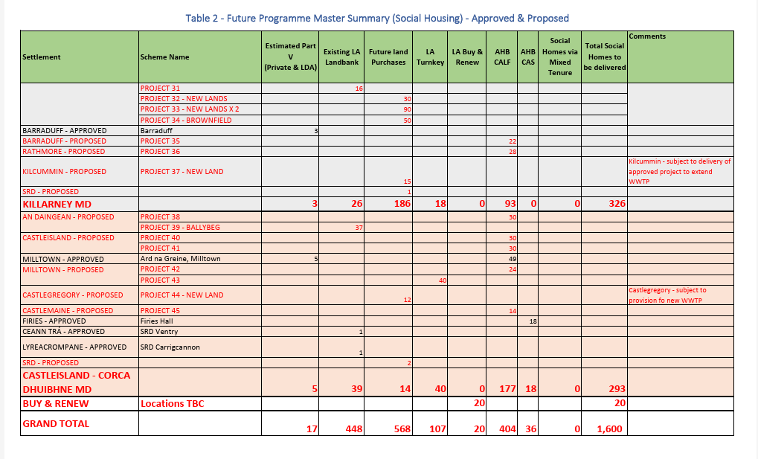

Scheme Stages
Planning permission was originally sought for the scheme in 2018 for a housing project. The application to revise the permission was submitted in January 2022, and approved in March 2022. Approval for CALF Funding by the Department of Housing, Local Government and Heritage was granted in March 2023. Construction on the project began in July 2023 with completion of the units and delivery to Cluid taking place in December 2024.

Project Location
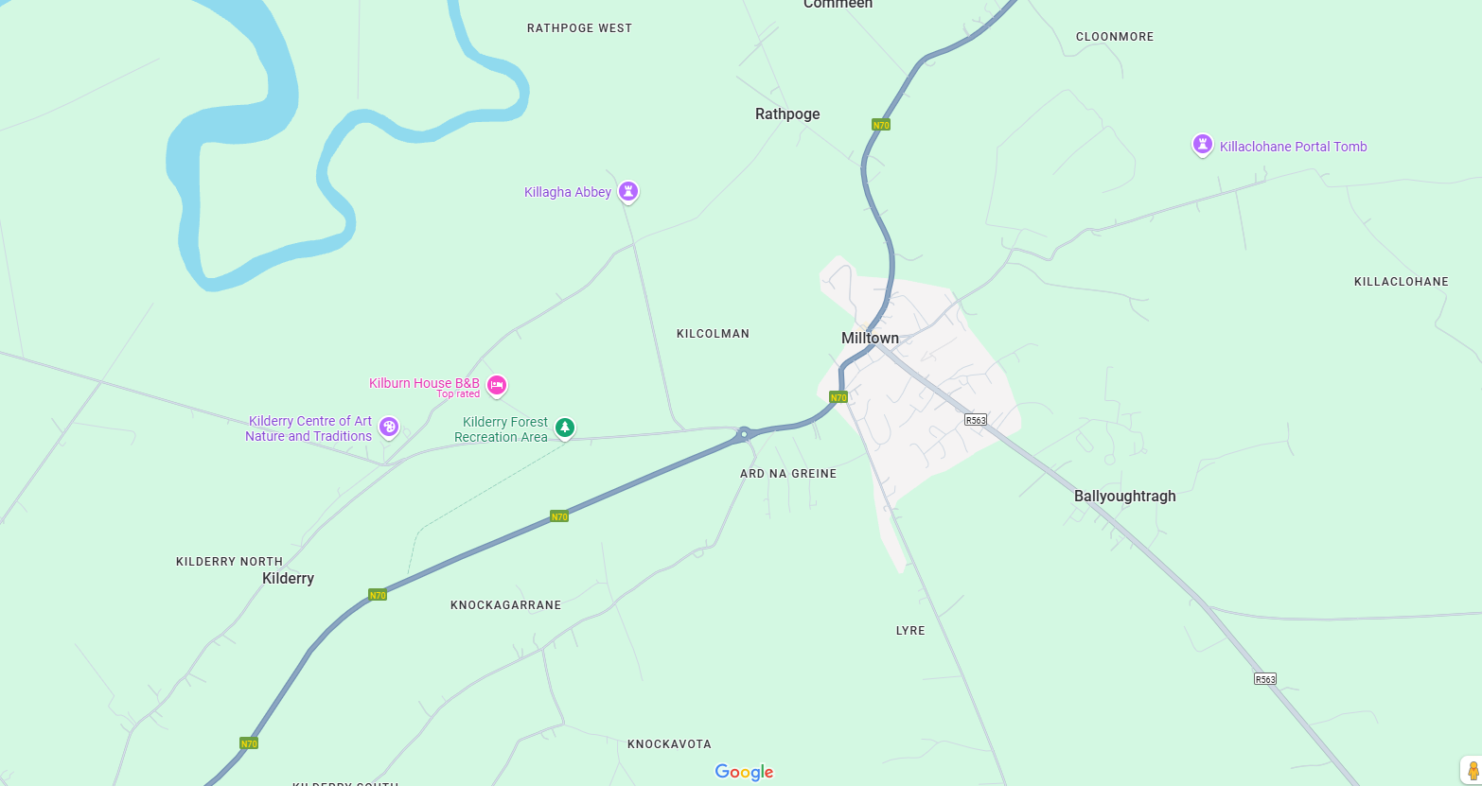

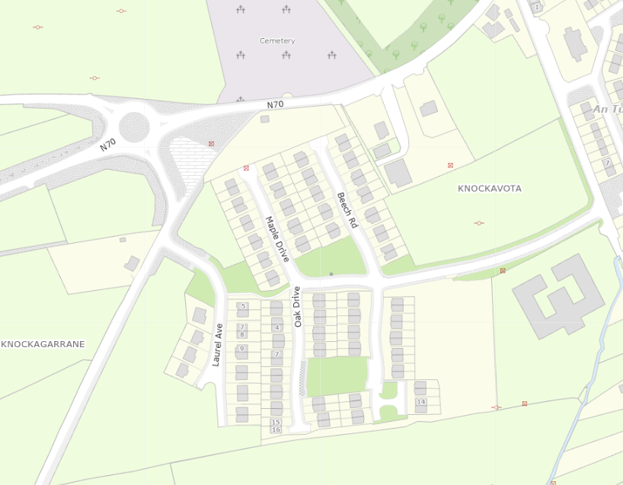

The site is located off the main Tralee-Killorglin road, on the Killorglin side of Milltown. Access to the housing project is via the L4035. On the map above, the project location is outlined in red.

Section B - Step 1: Logic Model Mapping
As part of this In-Depth Check, Internal Audit, Kerry County Council have completed a Programme Logic Model (PLM) for the Cherry Drive, Árd na Gréine Housing Development in Milltown. A PLM is a standard evaluation tool and further information on their nature is available in the Public Spending Code.

Objectives | Inputs | Activities | Outputs | Outcomes
The scheme is an objective for Kerry County Council as part of their Housing Programme, which is informed by the Housing for All Programme, Social Housing Need in Kerry and the Kerry Housing Strategy.  Kerry County Council’s Housing Capital Unit are responsible for the design, planning and construction of all of our new build social housing units throughout the County. They are also available for discussions regarding the provision of Turnkey developments with private landowners and developers as well as the acquisition of suitable zoned lands in the areas where Housing need has been identified in the Housing Delivery Action Plan.  Approved Housing Bodies including Housing Associations and Co-operatives also provide and manage social rented housing. They are private, not-for-profit organisations formed for the purpose of relieving housing need and Kerry County Council works closely with these bodies to ensure delivery of additional homes for persons on the housing waiting list. | Financial Resources (total scheme budget estimated €11.3m)  Staffing: Planners to approve the planning permission  Administrative sight to submit the CALF Funding Application  Financial and project oversight. | Planning Permissions,  Project Management oversight  Design Approval  Construction & Implementation.  Sourcing of tenants from the Kerry County Council social housing list. | Construction of 44 housing units by Cluid Housing, through funding progressed via Kerry County Council. | Provision of supported social housing for elderly members of the community and those with disabilities.  All tenants are taken from the Council’s housing list.  Reduction in the Kerry County Council Housing List.

Description of Programme Logic Model

Objectives: This scheme has provided an additional 44 properties to the social housing stock in Kerry. The project, although owned and constructed by Cluid Housing, is tenanted by individuals and families on the Kerry County Council social housing list. Given that the project is a supported development, tenancy will be targeted at the elderly and those with disabilities, allowing them independent living, while assistance and security will also be available in the scheme.

Having regard to the targets for the provision of additional housing in Kerry through Housing for All Programme, the project is also consistent with the need for social housing identified in Kerry County Council’s Housing need and also their Delivery Action Plan. The Geographical distribution of Social housing Demand and approved delivery for 2022 supports this.

Inputs:
Financial Inputs: The primary input to the programme is the capital funding from the Department of Housing administered through Kerry County Council’s Housing Department.

Human Inputs: The project is managed by Cluid Housing. However, Kerry County Council provided oversight on the project and processed and managed the application for funding to the Department of Housing and also managed the drawdowns. Following completion of the project, staffing resources were utilised in identifying tenants for the properties from Kerry County Council’s social housing list.
System Inputs: The systems used for the Scheme included Kerry County Council’s Housing Strategy, and Housing Need reporting documents and the Agresso Financial Management System.
Activities:
Kerry County Council Housing Capital staff monitor the project during the construction, included ensuring the scheme as planned is in compliance with Kerry County Council’s housing need and planning requirements. Also, financial oversight is provided during the drawdown process.

Outputs:
Once completed, the 44 properties in the Mid Kerry area will house a number of elderly persons and persons with a disability, providing them with independent living within a supported community. These persons will be taken from Kerry County Council’s social housing list.

Outcomes:
The outcomes of the project will ensure the availability of 44 homes for those capable of independent living, but in need of support in a safe and secure environment. Now in the Mid Kerry area they will have access to own-door permanent housing, homes that they can call their own.

Section B - Step 2: Summary Timeline of Project/Programme

The following section tracks Árd na Gréine Housing Development from inception to conclusion in terms of major project/programme milestones.

Key Deliverables/Milestones | Dates
Project Planning Application | June 2018
Planning Application Approval | January 2019
Application for CALF Funding | February 2020
Approval of CALF Funding | June 2020
Commencement of Project | November 2020
Completion of Phase 1 | August 2022
Revised application for CALF Funding | October 2022
Approval of revised application | November 2022
Completion of Phase 2 | November 2022

Section B - Step 3: Analysis of Key Documents
The following section reviews the key documentation relating to appraisal, analysis and evaluation for the Cherry Drive, Árd na Gréine Housing Development, Milltown.
Project/Programme Key Documents
Title | Details | Quality of Document
- Planning Application  - Drawings  - Maps | Documents were compiled to apply for planning permission. They outline the project plan, detailed site and dwelling drawings, water and wastewater details, traffic management etc | Projects are clear, easy to read and well laid out. They show the steps of the planning process, from application, through to consultation with statutory bodies and the grant of planning permission with conditions.
- Correspondence  - Agreement/Approval letters | These documents indicate the communication between Cluid and Kerry County Council in relation to the proposed project and projected funding. | Documents show the nature of the discussion between all parties
- Requests for funding  - Correspondence seeking further information  - Approval of funding | These documents relate to applications to the Department of Housing for funding for the project | Documents are clear and show the rationale for seeking funding.
- Signed Delegation Orders / Chief Executive Orders | Order of Chief Executive to record and certify decisions made. | Chief Executive Orders are brief and clear.
- Expenditure reports  - Correspondence re ongoing progress of project. | Expenditure Reports outline level of expenditure against budget and are used to manage financial performance and support drawdown and recoupment claims. | Reports are standard financial reports from the Agresso Financial System. They clearly outline expenditure and serve the purpose for which they were intended.  Supporting back up documentation was also available to demonstrate that a procurement process was undertaken for expenditure which had been incurred.

Section B - Step 4: Data Audit
The following section details the data audit that was carried out for the Cherry Drive, Árd na Greine Project. It evaluates whether appropriate data is available for the future evaluation of the project/programme.

Data Required | Use | Availability
Housing Need in Kerry | Assess need for social housing project | Yes- Housing for All Programme, with outputs for Kerry available.  Housing need in Kerry assesses on a town-by-town basis the housing need.  Social Housing List
Expenditure | Manage budgets & monitor expenditure. Financial information required for TII claims | Yes- from the Financial Management System

Data Availability and Proposed Next Steps

The data available was taken from the various housing documents for Kerry, which outline both the level of housing need, the number of households seeking social housing and the targets for provision of housing as set out by the Housing for All Programme.

Once the scheme is finalised and the houses allocated to tenants, Kerry County Council’s social housing list will be amended to reflect this

Section B - Step 5: Key Evaluation Question
The following section looks at the key evaluation questions for Cherry Drive, Árd na Gréine project based on the findings from the previous sections of this report.

Does the delivery of the project/programme comply with the standards set out in the Public Spending Code? (Appraisal Stage, Implementation Stage and Post-Implementation Stage)
Internal Audit is satisfied that the project objective was clearly defined and that the needs that were to be met were outlined. There is satisfactory evidence to date of planning, appraisal, operational management, decision making and oversight/ governance.

Is the necessary data and information available such that the project/programme can be subjected to a full evaluation at a later date?

Data required to access the effectiveness of the project and the realisation of the scheme objectives can be obtained from the Housing for All Programme, Assessment of Need for social housing in Kerry, broken down on a geographical basis.
Additional information would have been received from elected members from the area, seeking additional social housing for constituents and the number of families on the social housing list in Kerry in the area.

What improvements are recommended such that future processes and management are enhanced?
Where such projects are ongoing, it is recommended that communication between the project owners/managers and local authority be filed separately for ease of access.

Section: In-Depth Check Summary
The following section presents a summary of the findings of this In-Depth Check on the Cherry Drive, Árd na Gréine Housing Development, Milltown.

Summary of In-Depth Check
This project was progressed through planning, design and construction during 2022. Permission was sought in January 2022, granted in March 2022 and funding was approved in 2023. Construction began in 2023 and completed in 2024.

To date the project presents a clear audit trail of the project from inception to its current status. It is Internal Audit’s opinion that the documentation provides satisfactory assurance that there is broad compliance with the Public Spending Code. Internal audit has made one minor recommendation.

Quality Assurance – In Depth Check
Section A: Introduction

This introductory section details the headline information on the programme or project in question.

Programme or Project Information
Name | Killarney URDF Public Realm
Detail | The project consists of Public Realm improvements incorporating shared spaces, improved accessibility with wider footpaths, landscaping to create a pedestrian friendly town centre with improved connectivity with Killarney National Park.
Responsible Body | Kerry County Council
Current Status | Expenditure Being Incurred
Start Date | February 2023
End Date | Projected December 2028
Overall Cost | €12.0m

Project Description
The aim of the project is to achieve the revitalisation of High Street, New Street, Kenmare Place to Main Street, Beech Road, and College Street with high quality enhanced public spaces in order to provide an attractive, cohesive public realm incorporating the principles of urban design while also retaining and capitalising on the existing character of the town. The vision is to create an attractive vibrant public realm, with a unique sense of identity. The project consists of Public Realm improvements incorporating shared spaces, improved accessibility with wider footpaths, landscaping to create a pedestrian friendly town centre with improved connectivity with Killarney National Park.

Project History
The Urban Regeneration and Development Fund (URDF) which is administered by the Department of Housing, Local Government and Heritage, aims to deliver more compact and sustainable development, as envisaged under Project Ireland 2040. It does this by part-funding regeneration and rejuvenation projects in Ireland’s five cities and other large towns. Currently, the URDF part-funds 132 projects, comprising of almost 400 subprojects, right across the country. More compact and sustainable development involves a greater proportion of residential and mixed-use development within the existing built-up footprints of our cities and towns. This will ensure more parts of our urban areas become attractive and vibrant places in which to live, work, visit and invest.

One of four funds set up under the National Development Plan 2018-2027, the URDF supports the objectives of the National Planning Framework (NPF). With an initial allocation of 2 billion euro up to 2027, the fund has been extended to 2030 under the revised NDP 2021-2030.

The upgrades scheme area encompasses the following streets, High Street, New Street, College Street, Kenmare Place to Main Street, Beech Road; and a number of smaller laneways which interlink these streets. These streets form much of the principal streets of the town centre and contain many of the town’s commercial, entertainment and service industry orientated businesses. The built environment of the subject area predominantly dates from the19th and 20th-centuries.

Need for the Scheme
The core objectives of the Project are: -
      - To create an attractive vibrant Landscape Architect designed public realm, with a unique sense of identity,
- where people can congregate and enjoy the diverse spaces created in a safe and accessible manner.
- To incorporate the “Principals of Universal Design” into the project from the outset.
- To highlight opportunities to integrate and increase permeability between the Town Centre and the Killarney National Park.
- Optimise the design to ensure Killarney Town centre is a pedestrian and cycling friendly environment.
- Incorporate Sustainable Urban Drainage Systems throughout the design, in accordance with Department of Housing, Local Government and Heritage publication on “Nature-Based solutions to the Management of Rainwater and Surface Water Runoff in Urban Areas”

The Kerry County Development Plan 2022-2028 outlines a number of objectives for the development of such a project. Similarly, the Killarney Municipal District Local Area Plan 2018-2024 also highlights certain objectives which promote this scheme.
Kerry County Development Plan
Objective KCDP 4-11: Facilitate and support initiatives to strengthen and improve the physical environment of the towns and villages with enhanced streetscapes, appropriate shopfront design and provision of improved street lighting, public footpaths, and street furniture.
Objective KCDP 4-15: Promote the guidance principles set out in the ‘Urban Design Manual – A Best Practice Guide’ (2009), and in the ‘Design Manual for Urban Roads and Streets’ (2019) and promote a more pedestrian friendly environment through the provision of traffic calming measures and improved pedestrian infrastructure.
Objective KCDP 4-16: Ensure that all new town centre developments, including developments relating to the enhancement of civic spaces and streetscapes, are based on the principles of universal access.
Objective KCDP 4-17: Facilitate the development of sustainable compact settlements with the “10-minute” town concepts, whereby, a range of community facilities and services are accessible in short walking and cycle timeframes from homes, with walkways and link routes to Greenways or are accessible by high quality public transport services connecting people to larger scaled settlements delivering these services.
Objective KCDP 4-20: Facilitate the preparation of Public Realm Plans to address the challenges relating to the development of the town centre, focusing on the physical enhancement and improvement of the town centre through urban design measures and improved traffic management.
Objective KCDP 14-1:Deliver sustainable transport infrastructure investments as identified for the road network, public/rural transport, and walking/cycling infrastructure to facilitate and realise the 10-minute town concept.

Killarney Municipal District Local Area Plan
Objective KA 35: Sustainably plan for and facilitate the continued regeneration and renewal of Killarney’s Town Centre’s streets, public realm spaces, including parks, walkways and greenways in order to revitalise it as a prosperous, vibrant, attractive location in which to live, work, learn and visit.
Objective KA 36: Sustainably improve connectiveness throughout the town and sensitively orientate the town to the National Park.
Objective KA 37: Facilitate improvements to Killarney Town Centre Public Realm at the following locations: Kenmare Place, New Street / High Street/College Street and Beech Road link to the National Park and those projects funded through the URDF Application 2020.
Objective KA 38: Facilitate the preparation of a masterplan where appropriate and facilitate the redevelopment of the Glebe Craft Quarter.
Objective KA 39: Facilitate and support the development of outdoor seating infrastructure at appropriate locations to support outdoor dining and to enhance the vibrancy of the town centre.
Objective KA 76: Develop and promote a more cycle and pedestrian friendly network and ancillary infrastructure throughout Killarney, having regard to environmental designations in the area.
Objective KA 79: Facilitate the enhancement of Killarney as a 10-minute town.
Objective KA 80: Facilitate improvement of existing footpaths and road network and support future projects for footpaths and roads with the provision of amenity areas at appropriate locations.

Scheme Stages
The project has been broken into a number of phases
- Phase 1 - Main Street & Kenmare Place - Construction Start Q3 2025 – Construction Complete Q1 2026
- Phase 2 - New Street Upper & Market Cross - Construction Start Q3 2026 – Construction Complete Q1 2027
- Phase 3 - Beech Road & New Street Lower - Construction Start Q3 2027 – Construction Complete Q1 2028
- Phase 4 - College Square / College Street & Lewis Road - Construction Start Q3 2028 – Construction Complete 2028
- Phase 5 - High Street - Construction Start TBA – Construction Complete TBA

Scheme Location

The Scheme is located in the town centre of Killarney, County Kerry. The streets in question, High Street, New Street, Kenmare Place to Main Street, Beech Road, and College Street form part of the main thoroughfares in Killarney, both from a pedestrian and traffic viewpoint.

These streets serve as vital connection point, into the heart of Killarney. Their proximity to key areas of the town make them an essential gateway for both local residents and visitors, linking the urban centre with the surrounding natural attractions, including Killarney National Park which is adjacent to the scheme.

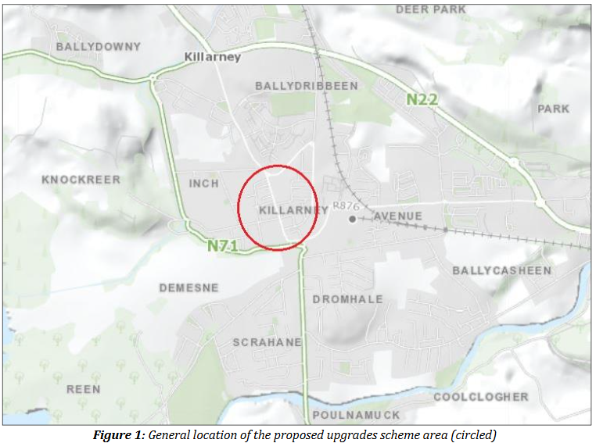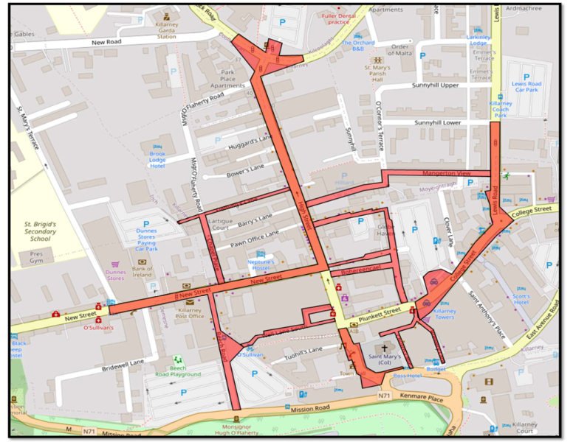

Section B - Step 1: Logic Model Mapping

As part of this In-Depth Check, Internal Audit, Kerry County Council have completed a Programme Logic Model (PLM) for the Killarney URDF Public Realm project. A PLM is a standard evaluation tool and further information on their nature is available in the Public Spending Code.

 | Objectives |  | Inputs |  | Activities |  | Outputs |  | Outcomes
The scheme is an objective for Kerry County Council and Killarney Municipal District as outlined in their Kerry County Development Plan 2022-2028 and as part of the Killarney Municipal District Plan 2018-2024 |  | Financial Resources (total scheme budget estimated €12.9m  Consultants.  Staffing Resources: Staff to manage the design and permissions phases of the project |  | Part 8 Planning Permissions,  Project Management oversight  Design Approval |  | The provision of shared spaces, improved accessibility with wider footpaths, landscaping and increased cycling-friendly spaces. |  | The revitalisation of High Street, New Street, Kenmare Place to Main Street, Beech Road, and College Street with high quality enhanced public spaces in order to provide an attractive, cohesive public realm incorporating the principles of urban design while also retaining and capitalising on the existing character of the town.  The vision is to create an attractive vibrant public realm, with a unique sense of identity.

Description of Programme Logic Model

Objectives: This scheme follows from the objectives outlined in both the Kerry County Development Plan 2022-2028 and as part of the Killarney Municipal District Plan 2018-2024 to enhance urban streetscapes and civic spaces, based on the concept of universal access, and to promote a more pedestrian friendly environment through the provision of traffic calming measures and more pedestrian friendly spaces.

Inputs: Financial Inputs: The primary input to the programme is the capital funding from the Urban Regeneration & Development Fund administered by the Department of Housing, Local Government and Heritage.

Human Inputs: The project is managed by the Kerry County Council Capital Design Unit (South). The staff are responsible for managing the design process, getting the necessary approvals, ensuring compliance with environmental, public consultation and planning requirements.

Consultants: Where the relevant specialist skills are not held within the unit, the staff of the Capital Design Unit (South) are responsible for the procurement of the relevant consultants to provide such specialist advice.

Activities: A few key activities are carried out in the early stages of the project include the drafting of designs for the various phases of the projects, procuring specialist advice and ensuring the relevant legislative requirements are followed. The process for obtaining planning permission through Part 8 of the Planning Act requires liaison with the elected members, publication of the relevant designs and reports, taking into consideration the views of the public through the Public Consultation Process and ensuring approval of the process by the Elected Members.

Outputs: Having been completed, the Public Realm project will lead to the provision of shared spaces, improved accessibility with wider footpaths, landscaping and increased cycling-friendly spaces. Such a development will lead to a more pedestrian and community friendly urban centre, with less emphasis on the motor car and greater universal access.

Outcomes: The outcomes of the project will lead to the revitalisation of High Street, New Street, Kenmare Place to Main Street, Beech Road, and College Street with high quality enhanced public spaces in order to provide an attractive, cohesive public realm incorporating the principles of urban design while also retaining and capitalising on the existing character of the town.
identity.

Section B - Step 2: Summary Timeline of Project/Programme

The following section tracks Killarney URDF Public Realm from inception to conclusion in terms of major project/programme milestones.

Key Deliverables/Milestones | Dates
URDF Funding Application | March 2020
URDF Funding Approval in Principle | August 2021
Approval of Preliminary Business Case | September 2022
Project Planning Application (Phase 1) | July 2025 (projected)
Proposed Construction Start (Phase 1) | Q3 2025 (projected)
Proposed Construction Start (Phase 2) | Q3 2026 (projected)
Proposed Construction Start (Phase 3) | Q3 2027 (projected)
Proposed Construction Start (Phase 4) | Q3 2028(projected)
Proposed Construction Start (Phase 5) | TBA

Section B - Step 3: Analysis of Key Documents
The following section reviews the key documentation relating to appraisal, analysis and evaluation for Killarney URDF Public Realm
Project/Programme Key Documents
Title | Details | Quality of Document
- Design Drawings  - Appropriate Assessment Screening Report  - Planner Report  - Environmental Impact Assessment Report  - Archaeological Assessment  - Planning Application  - Design Drawings  - Maps | Documents were compiled to complete the design of the project ahead of the application for planning permission for each phase. | Projects are clear, easy to read and well laid out.  They show the steps of the planning process, from application, through to consultation with statutory bodies through to the Planning Process.
- URDF Funding Application Documentation  - Correspondence  - Agreement/Approval letters | These documents indicate the communication between the Department of Housing, Local Government and Heritage and Kerry County Council in relation to the proposed project during the application stage, assessment and approval. | Documents show the nature of the discussion between all partied
- Signed Delegation Orders / Chief Executive Orders | Order of Chief Executive to record and certify decisions made. | Chief Executive Orders are brief and clear.
- Expenditure reports  - Correspondence re ongoing progress of project. | Expenditure Reports outline level of expenditure against budget and are used to manage financial performance and support drawdown and recoupment claims. | Reports are standard financial reports from the Agresso Financial System. They clearly outline expenditure and serve the purpose for which they were intended.  Supporting back up documentation was also available to demonstrate that a procurement process was undertaken for expenditure which had been incurred.

Section B - Step 4: Data Audit

The following section details the data audit that was carried out for Killarney URDF Public Realm Project. It evaluates whether appropriate data is available for the future evaluation of the project/programme.

Data Required | Use | Availability
Footfall & Traffic counters | Assess use of project area by motor vehicle traffic and pedestrians and gain a comparison following completion of the project. | Yes.
Expenditure | Manage budgets & monitor expenditure. Financial information required for Department claims | Yes- from the Financial Management System

Data Availability and Proposed Next Steps
The data available relates to expenditure. Regular expenditure reports are provided to Project Managers and Senior Management to ensure that the project continues to be progressed according to budget.

Section B - Step 5: Key Evaluation Questions

The following section looks at the key evaluation questions for Killarney URDF Public Realm based on the findings from the previous sections of this report.

Does the delivery of the project/programme comply with the standards set out in the Public Spending Code? (Appraisal Stage, Implementation Stage and Post-Implementation Stage)
Internal Audit is satisfied that the project objective was clearly defined and that the needs that were to be met were outlined. There is satisfactory evidence to date of planning, appraisal, operational management, decision making and oversight/ governance.

Is the necessary data and information available such that the project/programme can be subjected to a full evaluation at a later date?
Data required to access the effectiveness of the project and the realisation of the scheme objectives can be assessed against the objectives as set out in the Kerry County Development Plan 2022-2028 and the Killarney Municipal District Local Area Plan 2018-2024.

What improvements are recommended such that future processes and management are enhanced?
At this early stage of the process, no improvements on the future processes are apparent.

Section: In-Depth Check Summary
The following section presents a summary of the findings of this In-Depth Check on the Killarney URDF Public Realm Project.

Summary of In-Depth Check
This project was progressed through planning, design and application for funding and the first phase is currently going through the Part 8 Planning Process. To date the project presents a clear audit trail of the project from inception to its current status. It is Internal Audits opinion that the documentation provides satisfactory assurance that there is broad compliance with the Public Spending Code.

Quality Assurance – In Depth Check
Section A: Introduction
This introductory section details the headline information on the programme or project in question.
Programme or Project Information
Name | N70 National Secondary Route 5 Bridges Project
Detail | Project comprises of works on 5 No. Bridges on sections of the N70 National Secondary Route between Killorglin and Sneem, where the road is particularly deficient in terms of width and alignment.  The 5 locations are as follows:  1. Caragh Bridge  2. O’Connell’s Bridge (Gleensk)  3. Deelis Bridge (East of Cahersiveen)  4. Baslickane Bridge (south of Waterville)  5. Inchinaleega West/Lomanagh (West of Sneem)
Responsible Body | Kerry County Council
Current Status | Expenditure Being Considered
Start Date | October 2016
End Date | Funding Dependent
Overall Cost |  | €50m

Project Description
The aim of the project is to carry out works on five bridges on a section of the N70 National Secondary Road, between Killorglin and Sneem. The N70 is considered deficient in terms of width and alignment, and any upgrading works on the road would necessitate improvement works to 5 bridges which form part of this stretch of the N70.

These bridges are as follows:
- Caragh Bridge
- O’Connell’s Bridge (Gleensk)
- Deelis Bridge (East of Cahersiveen)
- Baslickane Bridge (south of Waterville
- Inchinaleega Weast (West of Sneem)

Project History
The National Secondary Roads (NSRs) are a key economic asset for Ireland that are necessary to connect our major cities and towns to each other and to the National Primary Roads. The existing NSR network comprises approximately 2,708 km of road on 34 routes throughout Ireland. The NSRs provide a hierarchical level of network connectivity between regional centres and to/from National Primary Roads. The network also provides for accessibility to areas of the country that have high amenity or tourism value or suffer from higher levels of social exclusion due to their peripheral location (e.g. routes such as the N56, N59, N67, N70 and N86). For the most part, however, the routes can be considered predominantly rural and inter-urban, and NSRs are generally defined by the following criteria:
- medium length through and semi-through routes;
- carrying medium to heavy volumes of traffic, with an annual average daily traffic (AADT) of over 2,000 vehicles;
- serving as connecting roads between principal towns;
- serving medium to large geographical regions;
- forming extensions to the National Primary Roads;
- linking National Primary Roads together to form a network.

The NSR network is thus an essential piece of national public infrastructure. It interacts with the National Primary Roads to facilitate the movement of strategic traffic throughout the island of Ireland, and it facilitates access and safety and sustains national development.

As far back as 1998, the National Road Needs Study identified serious deficiencies in the national road network and identified improvements needed to bring the network in Ireland up to a good standard. The NRA commissioned a National Road Secondary Road Needs Study, to identify National Secondary Roads or sections of a route suitable for investment to a higher design standard. The principal output from the NSRNS is a prioritised list of routes for investment under the proposed National Secondary Road projects, as well as a set of routes to be considered in other NRA programmes (i.e. maintenance, safety or major projects).

As part of the National Road Secondary Road Needs Study, the N70 was surveyed and the findings contained in the National Secondary Roads Needs Study- Network Options Report- South West Region – March 2011. This identified sections of road in need of improvement and as part of the survey, identified a number of bridge structures in the stretch of the N70 between Killorglin and Sneem which would require to be either improved or replaced to bring the route up to standard. Subsequent to this, Transport Infrastructure Ireland carried out technical inspection reports on all five bridges in between 2015 and 2017.

Need for the Scheme

As part of the National Road Secondary Road Needs Study, the N70 was surveyed, with the survey broken into sections of the route. The table below outlines the results of the survey and costings relating to bringing the road up to standard.

Reference Number | Description | Road Standard | Budget Cost (May 09) €m | AADT | Red Flag
N70b.1.T2 | Killorglin to Glenbeigh | T2 | 26.316 | 11000 | Yes
N70b.2.T3 | Glenbeigh to Cahersiveen | T3 | 47.406 | 7300 | Yes
N70c.1.T3 | Cahersiveen to Waterville | T3 | 19.736 | 1400 | Yes
N70d.1.T3 | Waterville to Caherdaniel | T3 | 31.682 | 2200 | Yes
N70d.2.T3 | Caherdaniel to Castlecove | T3 | 11.846 | 2200 | Yes
N70d.3.T3 | Castlecove to Sneem | T3 | 26.510 | 2200 | Yes

Kerry County Development Plan
The Kerry County Development Plan 2022-2028 outlines the importance of both national Primary and Secondary routes within the county.

National Primary and Secondary Routes The national route network comprises both the National Primary and Secondary Roads within the County. These routes are of vital economic importance, linking the County with other major centres and ports and are important arteries within the County itself.

These routes due to the landscapes they traverse and, in some locations the established enclosed nature of the road corridor and verge treatment are of significant tourism importance, however their primary role remains as transport and economic corridors.

It is an overall objective of the Plan to provide for balanced growth throughout the County by promoting the strengthening of rural communities and to provide sustainable infrastructure to facilitate job creation in these areas. The road network throughout the County and particularly the national road network is a vital element of this infrastructure. It is essential that they are maintained to the highest standards possible and that their efficiency, safety and carrying capacity is maximised. The creation of additional entrances onto these roads reduces their carrying capacity and safety and is contrary to the overall objective of improving the infrastructure serving rural areas.

A number of objectives within the Kerry County Development Plan 2022-2028 outline the need for improvements to the road infrastructure in the county:
Objective KCDP 14-20: Enhance and improve regional connectivity through upgraded transport infrastructure and effective public transport services
Objective KCDP 14-22: Protect and sustainably develop the County’s principal transportation assets including ports, Kerry Airport and strategic road and rail corridors.
Objective KCDP 14-26: Strengthen Steady State Investment in our existing road networks to ensure that existing networks are maintained to a high level to ensure quality levels of safety, service, accessibility and connectivity to transport users of all transport modes.
Objective KCDP 14-27: Provide or facilitate the sustainable provision of all road infrastructure projects set out in Table 14.3 with priority given to infrastructure serving the Key Towns.

The Regional Spatial and Economic Strategy lists key infrastructural projects required for balanced development of the Region and emphasise the link between the provision of infrastructure and land use planning. Building on the RSES, the priority road infrastructure requirements for the County are referenced in the County Development Plan and include the N70 Killorglin-Cahersiveen and Kenmare.

Scheme Stages
Following the National Road Secondary Road Needs Study in 2011, a technical inspection of the condition of the bridges was undertaken by Transport Infrastructure Ireland in 2017. Subsequently, Malachy Walsh & Partners Engineering & Environmental Consultants were engaged by the Kerry County Council National Roads Design Office to carry out feasibility studies on the five bridges. The feasibility studies were undertaken as part of, and having regard to, Phase 1 (Scheme Concept and Feasibility Studies) of the NRA 2010 Project Management Guidelines. Each report provided options and recommendations for improvement works at the five bridges, in relation to improvement of the bridge structure itself, improvement to traffic flow and improvement to the safety of road users, with the overall result to bring the road up to a good standard at these locations.

Scheme Location
The Scheme is located on the N70 National Secondary Road between the towns of Killorglin and Sneem in the southern part of County Kerry on the Iveragh Peninsula. The bridges in question are located along the route and considered to have deficiencies in terms of road standards.
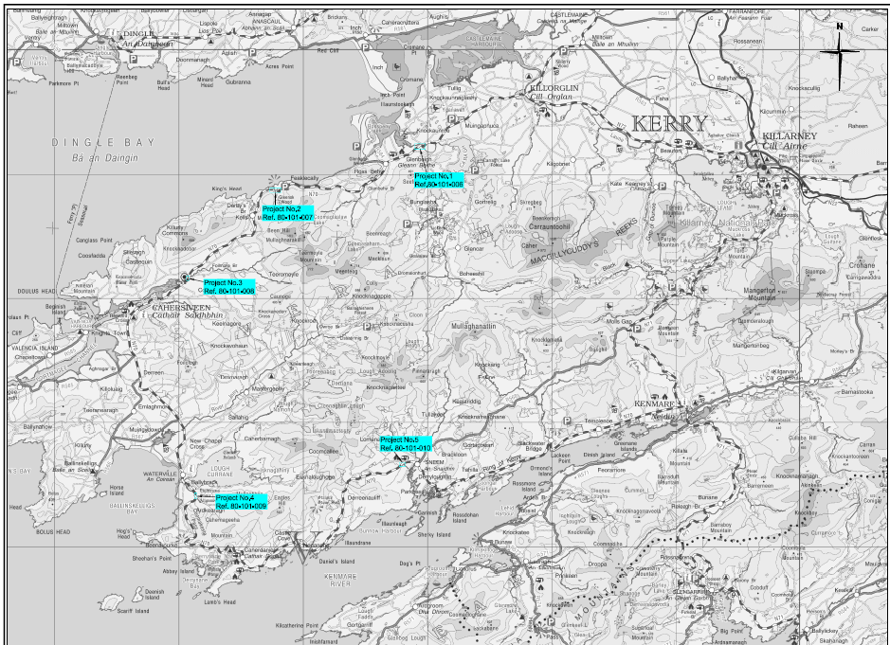

Section B - Step 1: Logic Model Mapping

As part of this In-Depth Check, Internal Audit have completed a Programme Logic Model (PLM) for the N70 National Secondary Route 5 Bridges Project. A PLM is a standard evaluation tool and further information on their nature is available in the Public Spending Code.

Objectives | Inputs | Activities | Outputs | Outcomes
The scheme is an objective for Kerry County Council as outlined in their Kerry County Development Plan 2022-2028.  It is also a finding in the National Road Secondary Road Needs Study that this road is deficient and the bridges form part of the work needed to bring them up to standard | Financial Resources (total scheme budget estimated €50  Consultants.  Staffing Resources: Staff to manage the process | Procurement of specialist consultants to produce feasibility report.  Liaison with the TII | The progressing of a project to improve the 5 bridges along the N70 road from Killorglin to Sneem. | Improvement of a strategic route in the south of the county.

Description of Programme Logic Model

Objectives: This scheme follows from the findings of the National Road Secondary Road Needs Study in 2011, which outlined that portions of the N70 road, particularly between Killorglin and Sneem were defective and below standard. The work involved requires bringing the road up to standard, which necessitates the upgrading of 5 bridges along the route. The importance and requirement to improve such National Secondary Routes in Kerry is also contained in the Kerry County Development Plan.

Inputs:
Financial Inputs: The primary input to the programme is the capital funding through Transport Infrastructure Ireland.

Human Inputs: The National Roads Office has responsibility for the project, and are responsible for procuring the necessary specialist expertise to carry out a feasibility report on the bridges and proposed options.

Activities:
Procurement of specialist external expertise to carry out feasibility report on the 5 bridges.
Liaison with the TII as to future funding requirements for such work

Outputs: The progressing of a project to improve the 5 bridges along the N70 road from Killorglin to Sneem.

Outcomes: The outcomes of the project will lead to an upgrading of a strategic route in Kerry from Killorglin to Sneem, which is critical to the local economy, particularly for tourism, as it forms a key part of the Ring of Kerry Tourist Route.

Section B - Step 2: Summary Timeline of Project/Programme
The following section tracks the N70 National Secondary Route 5 Bridges Project from inception to conclusion in terms of major project/programme milestones

Key Deliverables/Milestones | Dates
National Road Needs Study | 1998
National Road Secondary Road Needs Study | 2011
Transport Infrastructure Ireland Technical Inspection | 2017
Malachy Walsh & Partners Feasibility Report | 2018

Section B - Step 3: Analysis of Key Documents
The following section reviews the key documentation relating to appraisal, analysis and evaluation for N70 National Secondary Route 5 Bridges Project.

Project/Programme Key Documents
Title | Details | Quality of Document
- National Road Needs Study  - TII Technical Inspections  - Feasibility Studies | Documents were compiled at national and local level to obtain an overview of the road condition of the National Secondary Road network in Ireland  Additional reports were carried out on the 5 bridges to the determine their condition | Projects are clear, easy to read and well laid out.
- Correspondence  - Agreement/Approval letters | These documents indicate the communication between the NRA, TII and Kerry County Council in relation to the proposed project as it advanced and to get approval to carry out a feasibility study on the 5 bridges. | Documents show the nature of the discussion between all parties
- Signed Delegation Orders / Chief Executive Orders | Order of Chief Executive to record and certify decisions made. | Chief Executive Orders are brief and clear.
- Expenditure reports  - Correspondence re ongoing progress of project. | Expenditure Reports outline level of expenditure against budget and are used to manage financial performance and support drawdown and recoupment claims. | Reports are standard financial reports from the Agresso Financial System. They clearly outline expenditure and serve the purpose for which they were intended.  Supporting back up documentation was also available to demonstrate that a procurement process was undertaken for expenditure which had been incurred.

Section B - Step 4: Data Audit
The following section details the data audit that was carried out. It evaluates whether appropriate data is available for the future evaluation of the project/programme.

Data Required | Use | Availability
Traffic data | Assess use of route by traffic gain a comparison following completion of the project. | Yes.
Expenditure | Manage budgets & monitor expenditure. Financial information required for Department claims | Yes- from the Financial Management System
Accident history for locations | To assess the number of accidents on the route and determine if, following completion of the project, the figures have improved | Yes

Data Availability and Proposed Next Steps
Significant data is available from the assessments that were carried out on the route, including traffic counts and accident history. As the scheme has not yet commenced, it would be appropriate that regular updates of both traffic numbers and accident history are carried out, so that when the scheme is completed, a comparison can be carried out to determine the impact of the works.

Section B - Step 5: Key Evaluation Questions
The following section looks at the key evaluation questions for N70 National Secondary Route 5 Bridges Project based on the findings from the previous sections of this report.

Does the delivery of the project/programme comply with the standards set out in the Public Spending Code? (Appraisal Stage, Implementation Stage and Post-Implementation Stage)
Internal Audit is satisfied that the project objective was clearly defined and that the needs that were to be met were outlined. There is satisfactory evidence to date of planning, appraisal, operational management, decision making and oversight/ governance.

Is the necessary data and information available such that the project/programme can be subjected to a full evaluation at a later date?
Data required to access the effectiveness of the project and the realisation of the scheme objectives is available. If the project advances, such information can be assessed against the data captured prior to the project beginning.

What improvements are recommended such that future processes and management are enhanced?
At this early stage of the process, no improvements on the future processes are apparent.

Section: In-Depth Check Summary
The following section presents a summary of the findings of this In-Depth Check.

Summary of In-Depth Check
This project is still under consideration and has only undergone a feasibility process.

To date the project presents a clear audit trail of the project from inception to its current status.
It is Internal Audit’s opinion that the documentation provides satisfactory assurance that there is broad compliance with the Public Spending Code.

Quality Assurance – In Depth Check
Section A: Introduction

This introductory section details the headline information on the programme or project in question.

Programme or Project Information
Name | Redevelopment of Áras Phádraig Building, Killarney
Detail | The project consists of demolition of the existing Áras Phádraig building and in its place construct a three-storey Theatre and Community building, a six-storey Primary Care Centre and a Public Plaza
Responsible Body | Kerry County Council
Current Status | Expenditure Being Incurred
Start Date | March 2022
End Date | Projected December 2028
Overall Cost | €18m

Project Description
The aim of the project is to re-develop the Áras Phádraig building and site, following its acquisition by Kerry County Council. The project consists of demolition of the existing Áras Phádraig building and in its place, to construct a three-storey Theatre and Community building, as well as a Public Plaza and revised entrance to Lewis Road. The new Theatre 1750m2 (200–250 seats) will include toilets, changing rooms, prop stores for performers, etc. The stage area will have the option to open out onto the public plaza. Stage lighting, sound system, and stage to incorporate platform. The Áras Phádraig Theatre and Community Building will also provide space for community and educational activity in the building. The Kerry Parents and Friends Association will have an Activity and Educational Room on the first floor with its own dedicated kitchen and facilities and there is also a studio space with kitchen and meeting rooms on the second floor. A Six-story, 5,200m2 Primary Care Centre will be constructed and funded by the HSE for healthcare services for Killarney town. As well as providing much needed HSE funded services, it will accommodate the provision of comprehensive primary care health services. A Public Plaza will be constructed in front of the new Áras Phádraig Theatre and will serve both the Theatre and the new Primary Care Centre. A retail unit/Cafe on the ground floor is to be included Public Realm Proposal for a new plaza. Minor Landscaping works, including the planting of new trees and shrubbery and provision of street furniture such as planting boxes, benches, and bike stands will also be included, as will the relocation of the existing Pedestrian Crossing to a position 30m south of its existing location on Lewis Road

Project History
The Urban Regeneration and Development Fund (URDF) which is administered by the Department of Housing, Local Government and Heritage, aims to deliver more compact and sustainable development, as envisaged under Project Ireland 2040. It does this by part-funding regeneration and rejuvenation projects in Ireland’s five cities and other large towns. Currently, the URDF part-funds 132 projects, comprising of almost 400 subprojects, right across the country. More compact and sustainable development involves a greater proportion of residential and mixed-use development within the existing built-up footprints of our cities and towns. This will ensure more parts of our urban areas become attractive and vibrant places in which to live, work, visit and invest. One of four funds set up under the National Development Plan 2018-2027, the URDF supports the objectives of the National Planning Framework (NPF). With an initial allocation of 2 billion euro up to 2027, the fund has been extended to 2030 under the revised NDP 2021-2030.

The existing property, which is situated on the Lewis Road, was donated by the Franciscan Friary in 2009 to Kerry County Council. The existing building (2,623sqm) comprises of a theatre, but given the age of the property, poor state of repair and limited use of the existing theatre, it was commonly agreed that a significant redevelopment project would be required. Following difficulties with the transfer of the site to Kerry County Council, this resulted in the site and building being left vacant for a number of years, until the transfer issue was finalised. In 2019, external consultants were engaged to develop a masterplan for the site and car park. Subsequently, Kerry County Council made an application to the Department of Housing, Local Government and Heritage under the URDF for the redevelopment of the site in March 2020, with approval in principle received in March 2022.

Need for the Scheme
The Kerry County Development Plan 2022-2028 outlines a number of objectives for the development of such a project. Similarly, the Killarney Municipal District Local Area Plan 2018-2024 also highlights certain objectives which promote this scheme.

In the Killarney Town Plan, the Áras Phádraig site is described as an ‘Opportunity Site’, 1 Ha in size, with development potential described as mixed cultural/heritage/community use with associated car parking provisions, and a Town Centre Zoning (M2) in the Killarney Town Plan as described in Volume 2 of the Kerry County Development Plan 2022-2028. Development objectives are also included which support the proposal.

It is also considered that as the Áras Phádraig site has been left vacant and derelict for several years, the redevelopment of this site will bring back to life this area of the town and provide much needed new state of the art theatre. The new development will cater for both vehicular and pedestrian traffic and includes provision of car and bicycle parking. Measures laid out in the Mobility Management Plan for the project will aim to reduce the number of people travelling to and from the development by car, promote the use of public transport and encourage users to use more sustainable methods of travelling.

Kerry County Development Plan
Objective KCDP 4-11: Facilitate and support initiatives to strengthen and improve the physical environment of the towns and villages with enhanced streetscapes, appropriate shopfront design and provision of improved street lighting, public footpaths, and street furniture.
Objective KCDP 4-15: Promote the guidance principles set out in the ‘Urban Design Manual – A Best Practice Guide’ (2009), and in the ‘Design Manual for Urban Roads and Streets’ (2019) and promote a more pedestrian friendly environment through the provision of traffic calming measures and improved pedestrian infrastructure.
Objective KCDP 4-16: Ensure that all new town centre developments, including developments relating to the enhancement of civic spaces and streetscapes, are based on the principles of universal access.
Objective KCDP 4-20: Facilitate the preparation of Public Realm Plans to address the challenges relating to the development of the town centre, focusing on the physical enhancement and improvement of the town centre through urban design measures and improved traffic management.

Killarney Municipal District Local Area Plan
Objective KA 35: Sustainably plan for and facilitate the continued regeneration and renewal of Killarney’s Town Centre’s streets, public realm spaces, including parks, walkways and greenways in order to revitalise it as a prosperous, vibrant, attractive location in which to live, work, learn and visit.
Objective KA 37: Facilitate improvements to Killarney Town Centre Public Realm at the following locations: Kenmare Place, New Street / High Street/College Street and Beech Road link to the National Park and those projects funded through the URDF Application 2020.

Scheme Stages
The site was originally handed over by the Franciscan Friary in 2009, but legal issues prevented the transfer of the title to Kerry County Council for some years. A Masterplan for the site was developed in 2019, which formed the basis for the application to the Department of Housing, Local Government and Heritage in March 2020.

Approval in Principle was granted by the Department in March 2022. Subsequently detailed design plans and consultation with the elected members took place in order for the project to go into the planning approval stage. The Part 8 Planning Application went on public display on May 7th 2025, with a closing date for the public consultation period on June 5th 2025. Following this, a Chief Executive’s report on the submissions and the Council’s response to them will go before the elected members of Killarney Municipal District for decision.

Scheme Location
The Áras Phádraig site is located 300m east of Killarney Town Centre. It is accessed directly from Lewis Road which is a busy urban road connecting College Street with the N22 Killarney Bypass. The Friary church and Kerry Diocesan Youth Service KDYS are located to the east of the Áras Phádraig building. The existing car park is located to the north of the Áras Phádraig building. There are residential developments to the north and east of the site.

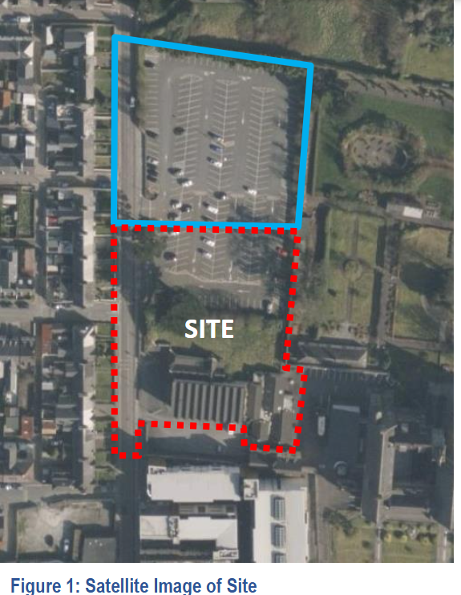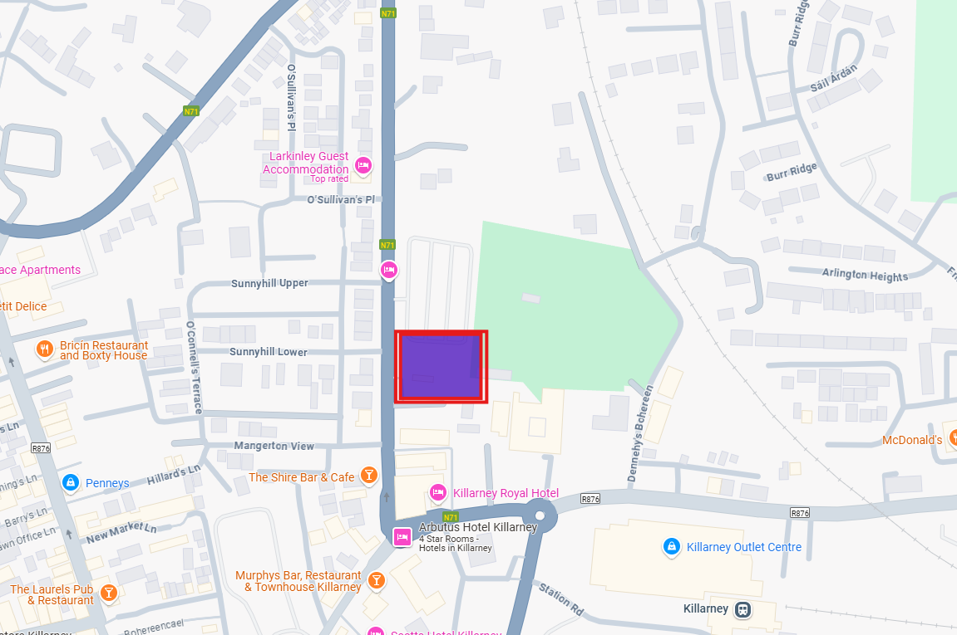

Section B - Step 1: Logic Model Mapping

As part of this In-Depth Check, Internal Audit, Kerry County Council has completed a Programme Logic Model (PLM) for the Áras Phádraig redevelopment project. A PLM is a standard evaluation tool and further information on their nature is available in the Public Spending Code.

 | Objectives |  | Inputs |  | Activities |  | Outputs |  | Outcomes
The scheme is an objective for Killarney Municipal District as outlined in their Town Development Plan |  | Financial Resources (total scheme budget estimated €18m  Tendering for and appointment of external consultants.  Staffing Resources: Staff to manage the design and permissions phases of the project  Kerry County Council staff will be utilised to project manage the project. |  | Site Masterplan Development  Design Approval  URDF Application Funding  Part 8 Planning application  Project Management oversight |  | The development of a modern theatre for Killarney town, coupled with a public realm space and a building for HSE use |  | The revitalisation of a vacant site in the middle of Killarney town which has been designated as an opportunity site.

Description of Programme Logic Model

Objectives: This scheme follows from the objectives outlined in the Killarney Municipal District Plan 2018-2024 to enhance urban streetscapes and public realm spaces. It also fulfils the objective for the development of opportunity sites in the town centre, providing a space for the development of a HSE-based medical facility, as well as a modern-theatre.

Inputs:
Financial Inputs: The primary input to the programme is the capital funding from the Urban Regeneration & Development Fund administered by the Department of Housing, Local Government and Heritage.

Human Inputs: The project is managed by the Kerry County Council Capital Design Unit (South). The staff are responsible for managing the design process, getting the necessary approvals, ensuring compliance with environmental, public consultation and planning requirements.

Consultants: Where the relevant specialist skills are not held within the unit, the staff of the Capital Design Unit (South) are responsible for the procurement of the relevant consultants to provide such specialist advice.

Activities:
Activities carried out in the early stages of the project include the development of a Masterplan for the site and the adjoining car park. This required procuring specialist advice and ensuring the relevant legislative requirements are followed. The process for obtaining planning permission through Part 8 of the Planning Act requires liaison with the elected members, publication of the relevant designs and reports, taking into consideration the views of the public through the Public Consultation Process and ensuring approval of the process by the Elected Members.

Outputs:
Having been completed, the Áras Phádraig project will lead to the provision of a modern, medium-sized theatre, which can be used for community purposes, along with an adjoining public realm area for the centre of Killarney town. Additionally, as part of the transformative regeneration of the site and the general area, the development of a building for the HSE will add to the medical opportunities in Killarney town.

Outcomes:
The outcome of the project will add to the to the revitalisation of the Lewis Road/centre of Killarney town area, and comply with an objective of the Killarney Town Plan, improving an opportunity site, removing dereliction from a high-profile site in central Killarney, while providing more public amenities to the community.

Section B - Step 2: Summary Timeline of Project/Programme
The following section tracks the Áras Phádraig project from inception to conclusion in terms of major project/programme milestones.

Key Deliverables/Milestones | Dates
Transfer of Site | 2009
Development of Masterplan for site | 2019
Approval of Masterplan for site by Elected Members | November 2022
URDF Funding Application | March 2020
URDF Funding Approval in Principle | March 2022
Project Planning Application | July 2025 (projected)

Section B - Step 3: Analysis of Key Documents
The following section reviews the key documentation relating to appraisal, analysis and evaluation for the Áras Phádraig project.
Project/Programme Key Documents
Title | Details | Quality of Document
- Design Drawings  - Appropriate Assessment Screening Report  - Planner Report  - Environmental Impact Assessment Report  - Archaeological Assessment  - Planning Application  - Design Drawings  - Maps | The Masterplan for the site were developed by external consultants.  Following approval of the Masterplan by Killarney MD elected members, documents were compiled to complete the design of the project ahead of the application for planning permission. | Projects are clear, easy to read and well laid out.  They show the steps of the planning process, from application, through to consultation with statutory bodies through to the Planning Process.
- URDF Funding Application Documentation  - Correspondence  - Agreement/Approval letters | These documents indicate the communication between the Department of Housing, Local Government and Heritage and Kerry County Council in relation to the proposed project during the application stage, assessment and approval. | Documents show the nature of the discussion between all partied
- Signed Delegation Orders / Chief Executive Orders | Order of Chief Executive to record and certify decisions made. | Chief Executive Orders are brief and clear.
- Expenditure reports  - Correspondence re ongoing progress of project. | Expenditure Reports outline level of expenditure against budget and are used to manage financial performance and support drawdown and recoupment claims. | Reports are standard financial reports from the Agresso Financial System. They clearly outline expenditure and serve the purpose for which they were intended.  Supporting back up documentation was also available to demonstrate that a procurement process was undertaken for expenditure which had been incurred.

Section B - Step 4: Data Audit

The following section details the data audit that was carried out for Áras Phádraig Project. It evaluates whether appropriate data is available for the future evaluation of the project/programme.

Data Required | Use | Availability
Expenditure | Manage budgets & monitor expenditure. Financial information required for Department claims | Yes- from the Financial Management System

Data Availability and Proposed Next Steps
The data available relates to expenditure. Regular expenditure reports are provided to Project Managers and Senior Management to ensure that the project continues to be progressed according to budget
Section B - Step 5: Key Evaluation Questions

The following section looks at the key evaluation questions for Áras Phádraig redevelopment project based on the findings from the previous sections of this report.

Does the delivery of the project/programme comply with the standards set out in the Public Spending Code? (Appraisal Stage, Implementation Stage and Post-Implementation Stage)
Internal Audit is satisfied that the project objective was clearly defined and that the needs that were to be met were outlined. There is satisfactory evidence to date of planning, appraisal, operational management, decision making and oversight/ governance.

Is the necessary data and information available such that the project/programme can be subjected to a full evaluation at a later date?
Data required to access the effectiveness of the project and the realisation of the scheme objectives can be assessed against the objectives as set out in the Kerry County Development Plan 2022-2028 and the Killarney Town Plan.

What improvements are recommended such that future processes and management are enhanced?
At this early stage of the process, no improvements on the future processes are apparent.

Section: In-Depth Check Summary
The following section presents a summary of the findings of this In-Depth Check on the Áras Phádraig Redevelopment project.

Summary of In-Depth Check
This project was progressed through planning, design and application for funding and the first phase is currently going through the Part 8 Planning Process.

To date the project presents a clear audit trail of the project from inception to its current status. It is Internal Audit’s opinion that the documentation provides satisfactory assurance that there is broad compliance with the Public Spending Code.

Quality Assurance – In Depth Check
Section A: Introduction

This introductory section details the headline information on the programme or project in question.

Programme or Project Information
Name | Dale Road Phase 2
Detail | The project consists of the upgrading of 2.2km of an identified section of regional road in accordance with prescribed technical standards, statutory provisions and service requirements in a manner that addresses the significant defects identified in accordance with the project objectives.
Responsible Body | Kerry County Council
Current Status | Expenditure Being Incurred
Start Date | October 2020
End Date | April 2022
Overall Cost | €8.2m

Project Description

The aim of the project was upgrade a 2.2km portion of the R556 Ballinclogher to Rathscannell Dale Road in accordance with prescribed technical standards, statutory provisions and service requirements in a manner that addresses the significant defects identified in accordance with the project objectives. The road itself, an important transport link in North Kerry and also a critical tourism access route to the north of the county, had been long identified, both anecdotally and in roads reports as being sub-standard and in need of significant road improvement works. Given the prior improvement work carried out on an adjoining stretch of the R556 a number of years previously, which had significantly improved the road condition, and the history of traffic accidents on this stretch of road, an upgrade of this stretch of road had been a priority for Kerry County Council for a number of years.
Project History
An adjoining 2.3km section of this road north of Ballinclogher Cross was improved between 2006 and 2009 under a Specific Improvement Grant. This project involved the removal of the entire bog rampart and the construction of a new section of road with an 8.0m wide carriageway, verges and associated works. The section of road that is subject to this project is Ballinclogher Cross southward towards Abbeydorney to the townland of Rathscannell. see Figure 1: Project Location. This section was considered for similar improvement as a continuation of the previous project but was delayed due to the downturn in the economy. Notwithstanding works completed under previous restoration improvement programmes, the road had continued to deteriorate. Restoration improvements were completed in 2005 and again in 2011, but the road surface quality rapidly deteriorated each time. It was recognised that substantial funding would be required to upgrade it to an acceptable standard.

Need for the Scheme
As outlined above, despite there being works completed under previous restoration improvement programmes, the fact that the road was built on a bog-rampart meant that, notwithstanding the continuous investment in the road, it continued to deteriorate. The defects highlighted in the preliminary appraisal included:
    - It formed part of the legacy network and had not been designed in accordance with road design standards.
    - The existing carriageway width was 4.0m to 5.5m with no hard shoulder and minimal to no verges. See Photograph 1.1 and 1.2.
    - It traversed an elevated bog rampart at elevations ranging in height from 1.5m to 3.0m from the edge of carriageway to the surrounding land.
    - There were numerous hazards including service poles immediately adjacent to the carriageway.
    - Significant funding was required on an annual basis for emergency repairs.
    - Road edges were failing on a continuous basis requiring ongoing repair.
    - The provision of vehicle restraint barrier was not possible due to limited available width and the prevailing ground conditions.
    - The above combined to increase the risk of vehicles leaving the carriageway and increased the severity of potential collision, See Photograph 1.5.
    - There was an ongoing collision pattern relating to the defects identified.
    - The condition of the road resulted in the avoidance of journeys impacting on the economic development of a designated CLÁR region.

The development of the project aligned with the objectives of regional and local policy documents including:
- Kerry County Development Plan 2015-2021 and 2022-2028
- Kerry County Council Tourism strategy 2016-2022.
- Kerry Local Economic & Community Plan 2016-2021.
- South West Regional Planning Guidelines 2010-2022.
- Road Safety Authority, Road Safety Strategy, 2013-2020.

The R556 forms part of this Strategic Transportation Network in the county and the proposed project was deemed to be compliant with the following stated objectives:
- RD2 Facilitate the improvement of the quality of life of all citizens of the County by providing good quality environment, energy, communication and transportation infrastructure.
- RD3 Provide for balanced and sustainable growth throughout the County by promoting the strengthening of rural communities and to provide the infrastructure to facilitate job creation and to cater for the needs of industry.
- RD5 Facilitate the sustainable provision of the necessary infrastructure at appropriate locations, required to promote the sustainable economic and social development of the County.
- RD-17 Protect the capacity and safety of the national road and strategically important regional road network in the County and ensure compliance with the Spatial Planning and National Roads Planning Guidelines (January 2012) and the NRA Traffic & Transport Assessment Guidelines (2007).
- RD21 Sustainably strengthen and improve the road network including links, by-passes and relief roads with priority given to those serving the Hub and Regional/ District Towns and interconnection between such settlements
- RD23 Continue the ongoing sustainable upgrading, strengthening and improvement works on regional & local and tertiary roads in accordance with the objectives of this Plan.
- RD24 Sustainably upgrade and improve the major tourist routes within the County

In addition, the project was compliant with the following policies:

Kerry County Council Tourism strategy 2016-2022.
The proposed project is compliant with the following stated objectives:
- Improving road access to the County and within the County.
- Improving public transport connections between major towns and coastal villages.

Kerry Local Economic & Community Plan 2016-2021.

The proposed project is compliant with the following stated objectives:
- 1.11 – Connectivity – Maximise connectivity of the County through investing in sustainable communication and transport infrastructure in appropriate locations.
- 1.11.1 - Ensure the sustainable development and maintenance of a good road infrastructure within the county and good radial access into the county.
    - 1.11.1.2 - Develop plans for new and improved roadways in the county including inner relief roads, by-passes and other strategically important transport links.

The objectives for the project were developed in accordance with National Transport Planning Policy using the Common Appraisal Framework. The Preliminary Appraisal Report submitted to the Department of Transport in July 2018 had clearly defined objectives and outlined how the delivery of the project would achieve the objectives.

Traffic Counts
Traffic counts were undertaken within the extents of the project periodically in 2018 and these continued into 2019. The R556 is a busy regional road with Annual Daily Traffic (ADT) of 2741 vehicles with 4% Heavy Goods vehicles recorded in 2018. These values were projected to grow to 3,118 by 2036. The importance and impact of tourism in the county is demonstrated by the seasonal variability to the returned values. A traffic count undertaken during the summer months returned a peak daily traffic flow in excess of 3,508 (2018 values). This is projected to grow to almost 4,000 by 2036.

Numerous accidents have occurred along this section of road over the past number of years. The accidents consisted of material damage as a result of vehicles leaving the carriageway and landing on the adjoining lands, including residential gardens which varied between 1.5m and 3.0m below the existing road levels. Based on local information there were also a significant number of additional unreported accidents consisting of material damage only. There was a potential of serious injury to road users and/or property owners given the condition of the road and the close proximity of houses.

Scheme Location
The project is located on the R556 regional road. The R556 commences in Tralee town centre and travels north for approximately 19.5km through the village of Abbeydorney merging with the R551 south of the village of Ballyduff. The R556 forms part of the strategic transportation network as outlined in the Kerry County Council Development Plan and is the main access route to the hub town of Tralee for the residents of north Kerry and for the headquarters of international industry such as Dairy Master. This is a popular route for tourists accessing Ballybunion, the Wild Atlantic Way and Blue Flag Beaches in North Kerry. Large sections of this road are built on bog ramparts which require continuous monitoring and require regular maintenance in order to keep it to a reasonable standard.

Section B - Step 1: Logic Model Mapping
As part of this In-Depth Check, Internal Audit, Kerry County Council have completed a Programme Logic Model (PLM) for the R556 Ballinclogher to Rathscannell Dale Road Reconstruction Project. A PLM is a standard evaluation tool and further information on their nature is available in the Public Spending Code.

 | Objectives |  | Inputs |  | Activities |  | Outputs |  | Outcomes
The scheme is an objective for Kerry County Council as set out in the following documents:  - Kerry County Development Plan 2015-2021 and 2022-2028  - Kerry County Council Tourism strategy 2016-2022.  - Kerry Local Economic & Community Plan 2016-2021.  - South West Regional Planning Guidelines 2010-2022.  - Road Safety Authority, Road Safety Strategy, 2013-2020. |  | Financial Resources (total scheme budget estimated €7.1m  Traffic Analysis & Projections  Staffing Resources: Staff to manage the design, options selections and permissions phases of the project  Kerry County Council staff were utilised to project manage the project, which took place under the Direct Labour Model |  | Preliminary Appraisal Documentation prepared.  Planning & Design  Design Approval  DTTaS Funding application  Project Management & Construction Management  Procurement of Goods & Materials |  | The upgrading of a 2.2km portion of a strategic route in North Kerry |  | The upgrading of a significant and strategically important route for tourism and transport in North Kerry, a stretch of road which had a significant history of accidents.

Description of Programme Logic Model

Objectives: This scheme had long been identified as a priority for Kerry County Council, given the strategic importance of the route for both economic and tourist reasons and also given the accident history on the route.

Inputs:
Financial Inputs: The primary input to the programme is the capital funding from the Department of Transport, Tourism & Sport.

Human Inputs: Significant staffing resources were also provided to the project, in terms of the project appraisal, design and construction as the project was managed directly by Kerry County Council and also the construction phase was carried out using the direct labour model.

Activities:
Activities carried out in the early stages of the project included the preparation of the Preliminary Appraisal Documentation, which was submitted to the Department of Transport, Tourism & Sport for approval and preliminary funding.

Following this, the Capital Team of Kerry County Council carried out planning & design of the project and submitted same for funding, prior to getting approval of the project at the Listowel Municipal District meeting of July 2020. The project was managed directly by Kerry County Council, using the direct labour model.

Outputs: Having been completed, the project has resulted in the upgrading of a 2.2km portion of a strategic route in North Kerry, which is a significant strategic route with a history of accidents.

Outcomes: This has resulted in a modern, safe road where previously there had been a road built on a bog-rampart, with significant undulations and dips, resulting in an unsafe driving surface with little room for other road users (pedestrians & cyclists) due to the narrow nature of the road. This is important when looking at improving the cycling infrastructure in the county and climate change requirements.

Section B - Step 2: Summary Timeline of Project/Programme
The following section tracks R556 Ballinclogher to Rathscannell Dale Road Reconstruction Project from inception to conclusion in terms of major project/programme milestones.

Key Deliverables/Milestones | Dates
Project Preliminary Appraisal | July 2018
EIA Screening Report | March 2020
Appropriate Assessment Screening Report | March 2020
Part 8 Planning Application | March 2020
Part 8 Approval | July 2020
S179 Planning for Deposition of Inert Material | October 2020
Construction Commenced | October 2020
Completion | April 2022

Section B - Step 3: Analysis of Key Documents
The following section reviews the key documentation relating to appraisal, analysis and evaluation for R556 Ballinclogher to Rathscannell Dale Road Reconstruction Project
Project/Programme Key Documents
Title | Details | Quality of Document
- Preliminary Appraisal  - Design Drawings  - Appropriate Assessment Screening Report  - Environmental Impact Assessment Screening Report  - Part 8 Planning Application  - Maps | These documents were necessary to get approval from the Department of Transport, Tourism & Sport to proceed to the planning process | Projects are clear, easy to read and well laid out. They show the steps of the planning process, from application, through to consultation with statutory bodies through to the Planning Process.
- DTTaS Funding Application  - Correspondence with Department re funding  - Communication re Increase in Costings | These documents indicate the communication between the Department of Transport, Tourism & Sport and Kerry County Council in relation to the proposed project during the application stage, assessment and approval. | Documents show the nature of the discussion between all partied
- Signed Delegation Orders / Chief Executive Orders | Order of Chief Executive to record and certify decisions made. | Chief Executive Orders are brief and clear.
- Expenditure reports  - Correspondence re ongoing progress of project.  - Post Project Appraisal Document | Expenditure Reports outline level of expenditure against budget and are used to manage financial performance and support drawdown and recoupment claims.  Reasons for increase in expenditure | Reports are standard financial reports from the Agresso Financial System. They clearly outline expenditure and serve the purpose for which they were intended.  Supporting back up documentation was also available to demonstrate that a procurement process was undertaken for expenditure which had been incurred.  The Post Project Appraisal document outlined the reasons for the increase in expenditure on the project and where savings had also been found.

Section B - Step 4: Data Audit

The following section details the data audit that was carried out for R556 Ballinclogher to Rathscannell Dale Road Reconstruction Project. It evaluates whether appropriate data is available for the future evaluation of the project/programme.

Data Required | Use | Availability
Expenditure | Manage budgets & monitor expenditure. Financial information required for Department claims | Yes- from the Financial Management System
Traffic Counts | To determine how busy the road was during the Preliminary Appraisal project | Yes
Accident History | To determine the impact of the road conditions on driving conditions | Yes

Data Availability and Proposed Next Steps
The data available was taken from the various studies carried out prior to design, including traffic count and accident history. With the project having been completed it would be useful for both traffic numbers and accident history to be audited, to determine the success of the scheme in both traffic numbers on a busy strategic route and reduction in accident numbers.

Section B - Step 5: Key Evaluation Questions

The following section looks at the key evaluation questions for R556 Ballinclogher to Rathscannell Dale Road Reconstruction Project based on the findings from the previous sections of this report.

Does the delivery of the project/programme comply with the standards set out in the Public Spending Code? (Appraisal Stage, Implementation Stage and Post-Implementation Stage)
Internal Audit is satisfied that the project objective was clearly defined and that the needs that were to be met were outlined. There is satisfactory evidence to date of planning, appraisal, operational management, decision making and oversight/ governance.

Is the necessary data and information available such that the project/programme can be subjected to a full evaluation at a later date?
Data required to access the effectiveness of the project can be seen where traffic counts and accident history are revisited against those recorded prior to the project.

What improvements are recommended such that future processes and management are enhanced?
With the project completed the Post Project Appraisal outlines the project and how the project cost more than projected. These potential areas should be considered ahead of future roads projects.

Section: In-Depth Check Summary
The following section presents a summary of the findings of this In-Depth Check on the R556 Ballinclogher to Rathscannell Dale Road Reconstruction Project.

Summary of In-Depth Check
This project was progressed through planning, design and application for funding and construction. The project presents a clear audit trail of the project from inception to its current status. It is Internal Audit’s opinion that the documentation provides satisfactory assurance that there is broad compliance with the Public Spending Code and the post-project appraisal process outlines the reasons for overspend and areas where cost savings have been achieved.

Quality Assurance – In Depth Check
Section A: Introduction

This introductory section details the headline information on the programme or project in question.

Programme or Project Information
Name | Car Parking- Annual Programme
Detail | Kerry County Council provides parking for motor vehicles and motorcycles in its towns and villages around the county. Such parking is maintained and managed by the Roads & Transportation Directorate.
Responsible Body | Kerry County Council
Current Status | Expenditure Being Incurred
Start Date | 01/01/2024 (for expenditure reporting purposes)
End Date | 31/12/2024 (for expenditure reporting purposes. Note activities and services are ongoing)
Overall Cost | €2.7m

Project Description
County Kerry offers a variety of car parking options across its towns and tourist destinations, catering to both residents and visitors, both off-street parking in designated locations and on-street designated parking areas. The car parks are generally operated and maintained by Kerry County Council and are strategically located to serve both the town centres in the larger towns and to also facilitate parking for visitors in tourist destinations. As part of its role in operating car parks in the towns and villages across Kerry, the local authority spends funds in maintaining and operating the car parks. This includes the employment of traffic wardens to manage car parking both in Council-owned car parks and also for on-street car parking. There is also provision for loan charges, in relation to loans taken out for the development of new car parks.
Parking in council-managed areas is regulated under the County of Kerry Traffic and Parking Byelaws, which outline provisions for parking on public roads, including resident and disabled parking permits. As outlined above, enforcement is carried out by traffic wardens, and penalties may be issued for non-compliance. Enforcement of car parks and on-street parking is required to ensure the use of parking spaces are not abused and that visitors and residents in the town can use car parks without them becoming congested. Additionally, Kerry County Council provides parking permits for residents and businesses to allow for on-street and off-street parking without having to pay parking fees on a daily basis.
For the purpose of this check, an in-depth check was carried out on the management of the Car Parking Programme (B09), for which Kerry County Council incurred an expenditure of €2.7m The programme in question (B09) covers a number of areas including:
- Maintenance and Management of Car Parks: This provides for the management and maintenance of car parks throughout the county, including equipment, materials and general maintenance, provision for loan charges, pay parking systems and back-office systems to process payments.
- Operation of Street Parking: This provides for the costs associated with the operation of street parking in several towns around the county, and includes equipment, contract maintenance an coin collection costs.
- Parking Enforcement: This provides for the costs associated with the provision of year-round traffic warden services provided in a number of towns in Kerry: Cahirciveen, Castleisland, Dingle, Kenmare, Killarney, Killorglin, Listowel, Tralee and during the summer months in Ballybunion. Additionally, the administration costs of the traffic fines system is included.

Parking fees in council-owned car parks can typically be paid via:
- Pay-and-display machines: Accepting coins and sometimes card payments.
- Online portals: For managing permits and paying fines. kerrycoco.ie

Kerry County Council Car Parks
Car Parks owned and operated by Kerry County Council include:
- Brandon Car Park Tralee
- Parklands Car Park Tralee
- Garveys Car Park, Tralee,
- North Circular Road, Tralee
- St John’s Car Park, Tralee
- The Square Listowel
- Bridge Road Listowel
- Courthouse Road Listowel
- Dingle Marina
- Spa Road, Dingle
- Library Place Killorglin
- Cliff Road, Ballybunion
- Sandhill Road Car Park, Ballybunion
- Glebe Car Park Killarney
- New Street Car Park Killarney
- Rock Road Car Park Killarney
- Friary Car Park Killarney
- Fair Hill Car Park Killarney
- High Street Car Park Killarney
- Cahirciveen,
- Railway Road Kenmare
- Library, Castleisland

In Towns and Villages around Kerry, the significant number of visitors to the county, particularly coastal towns and villages and Blue Flag Beaches has resulted in the creation of car parks and parking areas, which are monitored and maintained by the Council and are covered by Council Parking By-laws or Beach By-laws to ensure enforcement.

Section B - Step 1: Logic Model Mapping

As part of this In-Depth Check, Internal Audit, Kerry County Council have completed a Programme Logic Model (PLM) for the ) for the Car Parking programme in Kerry. A PLM is a standard evaluation tool and further information on their nature is available in the Public Spending Code.

 | Objectives |  | Inputs |  | Activities |  | Outputs |  | Outcomes
To meet the demand for car parking for both residents and visitors alike across the towns, villages and tourist destinations of Kerry. |  | Financial Resources (€2.7m)  Staff-  - Administrative staff to manage the pay parking and fines process  - Traffic Wardens for enforcement of parking by-laws and regulations and to ensure car parks experience continual turnover of parking spaces.  - Technical staff and outdoor staff for the upkeep and maintenance of car parks. |  | Administration of Pay Parking to ensure pay parking machines are operational, and cash is collected from machines and car payments are also processed.  Use of courier services to process, transfer and lodge cash payments.  Enforcement of parking spaces by traffic wardens ensuring compliance with parking regulations, issuing of fines, ensuring fines are paid.  Continual monitoring of car parks, car parking requirements relating to seasonal demand and sourcing additional temporary car parking where possible to deal with high-season demand. |  | Provision of high-standard car parks in Kerry, adequate for the requirements of residents and visitors alike.  Maintenance of car parks at a high standard, and  Ensuring that illegal on-street car parking does not result in delayed traffic movements or restrict parking spaces. |  | Given the significant number of visitors to Kerry, particularly during the summer season, such work will ensure that there is a continual, regular number of parking spaces available for residents and visitors.

Description of Programme Logic Model

Objectives: The provision of car parking is critical for Kerry, not only in its towns and villages, but also in areas of high-scenic value, which attract large number of visitors. Parking is required for both residents and visitors to ensure safe parking which does not restrict traffic movement, to allow visitors and locals to park close to shopping areas and to attract more visitors to areas, with safe, designated parking areas.

Inputs:
Financial Inputs: Funding of €2.7m is budgeted for in 2024, which relates to expenditure on staffing, administration, and maintenance and management of car parks.
Human Inputs: Staffing resources are required for administering pay-parking, including the pay & displace machines, cash delivery, processing of card payments, cash delivery services, enforcement of parking regulations, processing of fines.
Activities: Activities carried out include administration of the pay-parking programme, pay & display machines, managing cash and card payments, issuing of traffic fines and managing payment of those fines. Continued monitoring of car parks ensures detection of issues, ensuring car parks are kept at a high-standard and pay & display machine outages are dealt with early, leading to reduction in downtime of these machines. In areas where there can be a high-demand for parking during high-tourist season, staff look to source suitable, available temporary parking to accommodate larger traffic numbers.

Outputs: Provision of high-quality car parks in towns, villages and areas of high scenic value. In addition, provision of parking enforcement for on-street car-parking to prevent disruption to traffic flow.

Outcomes: Towns and villages around Kerry benefit from the provision of high-quality car parks in areas of need, with enforcement ensuring that traffic flow in Kerry’s towns and villages is not impacted, while providing regular car parking spaces.

Section B - Step 2: Summary Timeline of Project/Programme
The following section tracks Car Parking Programme from inception to conclusion in terms of major project/programme milestones.

Key Deliverables/Milestones | Dates
Approval of Annual Budget of Kerry County Council | November 2023
Application by residents & business owners for parking permits for on-street & off-street Parking (available on a 3/6/12 month basis) | Jan-December 2024
Cash collection from Pay Parking Machines | Jan-December 2024 (x5 days a week)
Pay & Display receipting | Jan-December 2024 (weekly)
Credit Card Receipt- Agresso reporting | Jan-December 2024 (Monthly)

Section B - Step 3: Analysis of Key Documents
The following section reviews the key documentation relating to appraisal, analysis and evaluation for Car Parking Programme.
Project/Programme Key Documents
Title | Details | Quality of Document
Parking Byelaws | Provide the authority for the local authority to make laws in relation to the use and operation of car parks provided by them. | Clear documentation, outlining the car parks in question and the regulations relating to their use, as well as what is prohibited and the right for the local authority to charge parking fees.
Road Traffic Act 2002 (Sec 12)  Road Traffic Act 2004 (Part 3) | Provides the authority for Traffic Wardens to apply fixed charge fines relating to parking offences | Legislation is clear and provides the legislative background for Traffic Wardens to give out fines.
Kerry County Development Plan | Outlines the requirement for the provision of adequate car parking throughout the county for the proper functioning of settlements and access to services. | Clearly outlines the need for parking, which it acknowledges must be offset, in town centres, with the obligations to reduce overall car dependency in order to achieve climate change targets.
- Expenditure reports | Outlines the level of spending that the section or programme has undergone and provides detail on this. | Clear and easy to read, as it sets out in detail in what areas monies have been spent, and for what reason.
- Procedure Manuals | Procedure Manuals provide description of tasks and templates, provide standardised reporting and documentation | Procedure manuals are clear easy to read and well laid out. There are clear directions in the procedure manuals on how to process and advance the various tasks. It would be recommended that regular reviews of the manuals would be undertaken to ensure they are up to date.
- Operational Team Plan | Operational Team Plan | The Plan outlines the work of the departments.
- Risk Register 2024 | Undertaken in accordance with Kerry County Council’s Risk Management Policy | The Risk Register is reviewed and updated regularly to reflect current risks facing the Local Authority at Corporate and Directorate Level. The register identifies, classifies and outlines control of events and activities to which the Roads & Transportation Department are subject to. It is documented in accordance with the Risk Procedure of Kerry County Council. The risk register outlines the objective of enhancing the existing strategic transportation infrastructure, of which Car Parks form a part.
- Budget 2024 | Outlines the approved spend for Departments, and Kerry County Council | The Budget sets out clearly the budget for Kerry County Council for 2024, as approved by the Elected Members. It clearly breaks down the agreed spend for each section and programme.

Section B - Step 4: Data Audit

The following section details the data audit that was carried out for the Car Parking Programme. It evaluates whether appropriate data is available for the future evaluation of the project/programme.

Data Required | Use | Availability
Expenditure | Manage budgets & monitor expenditure. | Yes- from the Financial Management System
Daily & Weekly cash & card receipt payment details.  Pay Parking Machine information | Determines the activity in the car parks where Pay-Parking and machines are located. These give an accurate picture of how busy each pay-parking car park is and can help determine need.  On-Street Pay Parking Meters can also help to outline the need for car parking in a location | Yes
Parking Enforcement details | This relates to the issuing of parking fines by Traffic Wardens in Kerry. Again, it can provide necessary information on parking demand, areas where illegal parking occurs on a regular basis and provide information to Administrative and Engineering staff for possible issues. | Yes

Data Availability and Proposed Next Steps
The data available is available quickly, given that such information can be generated down to a granular level (i.e.: daily use). It can and has been used to determine need for additional parking in areas of high-demand and allow engineers, planners and administrative staff, in conjunction with traffic studies, possible additional need for parking around the county.

Section B - Step 5: Key Evaluation Questions

The following section looks at the key evaluation questions for the Car Parking Programme based on the findings from the previous sections of this report.

Does the delivery of the project/programme comply with the standards set out in the Public Spending Code? (Appraisal Stage, Implementation Stage and Post-Implementation Stage)
Internal Audit is reasonably assured that the B09 Car Parking Programme complies with the standards of the public spending code. There are suitable management structures and reporting requirements established to monitor activity and expenditure progress against budgets and there are internal controls within both the financial management system and procedure manuals to ensure good governance, separation of duties and approval limits.

Is the necessary data and information available such that the project/programme can be subjected to a full evaluation at a later date?
The provision of car parking and the ongoing maintenance and management of car parking in Kerry, both on and off-street is managed by the Roads & Transportation Department. Parking data collected provides strong information on the use of the parking spaces and can help identify parking and traffic trends that can be utilised for future plans.

What improvements are recommended such that future processes and management are enhanced?
It would be a recommendation that the procedure manuals held are subjected to regular review to ensure that they are current.

Section: In-Depth Check Summary
The following section presents a summary of the findings of this In-Depth Check on the Car Parking Programme B09.

Summary of In-Depth Check
Under Section 4 of the Quality Assurance provisions contained in the Public Spending Code Kerry County Council is required to carry out an in-dept review of a minimum of 1% of the total value of all Revenue Projects on the PSC Inventory list, averaged over a three-year period

It is Internal Audit’s opinion that the Car Parking programme is in broad compliance with the Public Spending Code. Internal Audit carried out an examination of documentation including expenditure reports, monitoring and progress reports, procedure manuals, operation plans and files. One recommendation relates to regular reviews of Procedure Manuals.

Evaluation proofing involves checking to see if the required data are being collected so that when the time comes a programme/project can be subjected to a robust evaluation. If the data are not being collected, then a plan should be put in place to collect the appropriate indicators to allow for the completion of a robust evaluation down the line.

