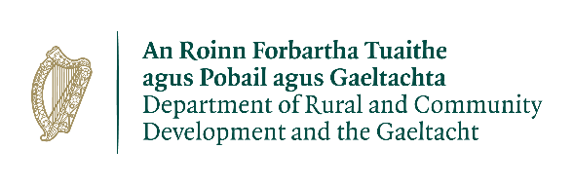
Expression of Interest Form
2026 Town and Village Renewal Scheme
Main Scheme
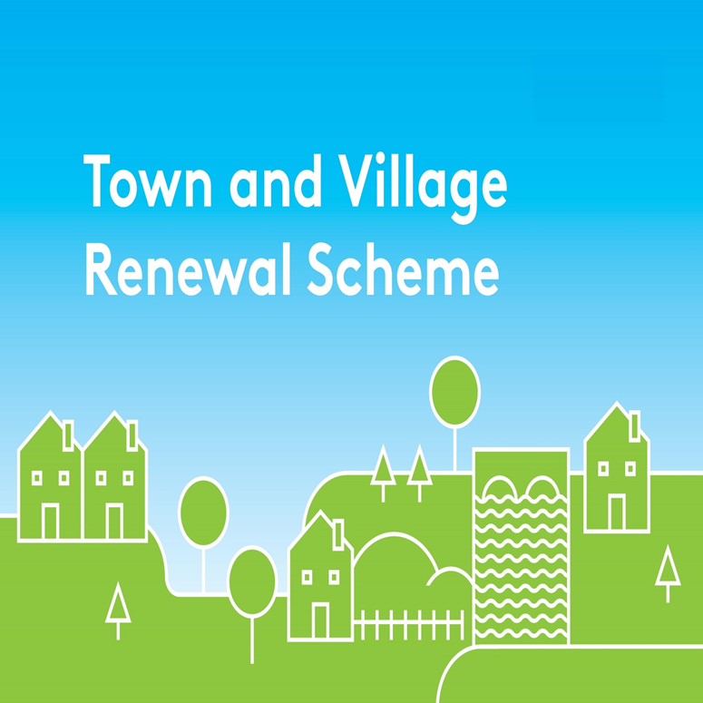
This Expression of Interest Form should be completed and returned in
word format only by e-mail to community@kerrycoco.ie
by Tuesday, 27th October, 2026.

(The deadline is set to allow all applications to be assessed in advance of the Local Authority submitting final applications to the Department of Rural and Community Development (DRCDG) and the Gaeltacht by Friday, 22nd January, 2027).

Queries should be referred to your local Municipal District Office or by email to the Community
Department at community@kerrycoco.ie or by phone to 066-7183680

Please Note: Any extension of the closing date cannot be facilitated in any circumstance.

Town and Village Renewal Scheme 2026

Town/Village covered:

Please indicate which category of funding is being applied for:

Category 1 Category 2 Category 3

Towns/Villages with Towns/Villages with Towns/Villages with

Population of 5,000 Population of Population up to

or less 5,001-10,000 15,000

Category 4

Pilot “Urban Towns”Category

Amount of Funding Requested:

Applicant Group:

Applicant Contact Name:

Applicant Contact Address:

Applicant Telephone Number:

Applicant Mobile Number:

Applicant Email Address:

Please provide the Eircode or XY (ITM format) coordinates of the project: XY coordinates should be captured in Irish Transverse Mercator (ITM) formats.
Coordinates can be converted to ITM format here: https://gnss.osi.ie/new-converter/. This data will be used to geo-map all successful projects.

- Has funding for this project ever been sought from other sources? Yes No
(If "YES" yes please specify from what source and if funding was provided)

- Please provide details of where any shortfall of funding for the project will be sourced.

- Who are the specific project stakeholders/community partners in this project?
(Chamber of Commerce, Community group, etc.).

- Project details:

- Permissions and Planning
- Does the proposed project involve works to a building/property or lands that are not in the ownership of the Local Authority or Local Community Partner? If yes, provide details of the current owner/s.
- If the building/property is not in the ownership of the Local Authority or community group partner, has permission has been granted by the owners to carry out the proposed works? A lease must be in place at project commencement date and for a minimum of 15 years from project completion date. Is this in place? If the building/property is in the ownership of the applicant, please provide a copy of the folio and if a lease agreement is in place please provide a copy of the lease agreement.
- Are all appropriate assessments, screenings and planning permissions in place? If yes, please provide a copy of the permissions/planning reference number if applicable.

- Has this town/village received public funding previously e.g. TVRS, TCF, CLÁR, ORIS, RRDF, LEADER, CCIF, CRF, URDF, TCRIF, Active Travel, Community Sport Facilities Fund, Fáilte Ireland etc.? If so, please list by scheme, year and funding amount.

- Are there any other applications pending for public funding for this project? (e.g. CLÁR, ORIS, RRDF, LEADER, CCIF, CRF, TCRIF, Active Travel, Community Sport Facilities Fund, Fáilte Ireland etc). If so, please list by scheme, year and funding amount requested.

- If this town/village is also the subject of an RRDF application, explain the rationale for submitting this application to the Town and Village Renewal Scheme and how this links with the RRDF application.

- Who will be implementing the project? Please provide details of other stakeholders involved. (Please note per the scheme outline, Section 7 Local Authority Costs, where works are to be undertaken in-house by the Local Authority, a breakdown of these costs must be included in the application form and a rationale provided for same. Where Local Authority staff costs are included they must be proportionate to the overall cost of the project, and identified at application stage)

- If seeking funding of between €300,001 and €500,000, please detail the particular case for this level of funding.

- What is the objective of the proposed project and how will the intended outcomes be measured? (Please identify any metrics or benchmarks that will be applied).

- Does the proposed project involve the upgrade or refurbishment to a Community Centre? Yes No
(If "YES" please complete the Community Centre Questionnaire)

- Does the project involve any form of remote working/enterprise/training hubs? Yes No
(If "YES" please complete the New Hub Developments Questionnaire)
- PROJECT COSTINGS:
Please provide a detailed breakdown of all elements of the proposed works including any professional fees/costs/signage etc: (please add additional rows for costs as required)

Project Element | Estimated Cost (inclusive of VAT)
1. e.g. signage | €
2. | €
3. | €
4. | €
Local Authority Costs, (if applicable)
1. | €
2. | €
Total Project Cost | €
Grant Aid amount sought:  (Max of 90% of total project costs) | €
Match Funding: (Min 10% of total cost): | €
Supplier of Match Funding

Any other relevant information:

2026 Town and Village Renewal Scheme
Community Centre Questionnaire

Description

What is the location of the community centre, include Eircode or XY (ITM format)?

Provide a rationale for the proposed renovation/refurbishment to existing community centre? (250 word max description)
Outline identified demand for the community centre and detail spaces/activities that will be available? (250 word max description)

What is the distance from this community centre to the next nearest community centre/facility?

Has public funding been provided to this community centre / facility or another community facility in the locality in the last 5 years?

Is this community centre located in the centre of a town or village? If not, what is the distance to the town or village centre?

Are the proposed works to the community centre ready to go (are all consents in place)?

Is planning permission required? If so, this must be in place at time of application.

When is the timeline for completion of the works, and when would it be opening to the public?

What involvement has the local community had in this process to date?

Has a Building Inspection Report / Building Survey been carried out by a qualified Architect/Surveyor? Have any issues been identified?

2026 Town and Village Renewal Scheme
New Hub Developments Questionnaire
 | Description
1 | What type of hub is being proposed (select from list appended to scheme outline: Enterprise Hub; Scaling Hub; R&D, Co-Working; Community/Enterprise Hub)?
2 | What type of workspace will be developed (250 word max description)?
3 | Provide a rationale for the development of a Hub in this location, and include identified demand for the service, and detail services that will be available? (250 word max description – include reference to the number of seats)
4 | What will be the size of the hub (square footage)?
5 | Is the building proposed for the hub currently vacant/disused?
6 | Is the project shovel ready (are all consents in place)?
7 | When is the expected opening date for the Hub?
8 | What is the distance, in kilometres from the proposed new Hub to an existing Hub?
9 | Please list all hubs and their categorisations within a 45 km radius (reference map).
10 | What gap is the hub proposing to fill (250 word max description with reference to q1 and q8)?
11 | Who is the Hub’s target audience (250 word max description)?
 | How will the Hub be marketed to users?
 | What involvement has the local community had in process to date?

DECLARATION
I hereby confirm that I have read and understand this document. I request that consideration be given in support of the project as outlined above.

Signature __________________________________________________

Position __________________________________________________

Date __________________________________________________

Kerry County Council’s Community Department reserves the right to publish a list of all grants awarded on its website www.kerrycoco.ie.

All personal data collected is in compliance with the requirements of the General Data Protection Regulation (GDPR) 2016 and Data Protection Acts 1988 to 2003. Individual privacy notices for each section/service are available at www.kerrycoco.ie.

