Expression of Interest Form
Town & Village Renewal Scheme 2026
Project Development Measure

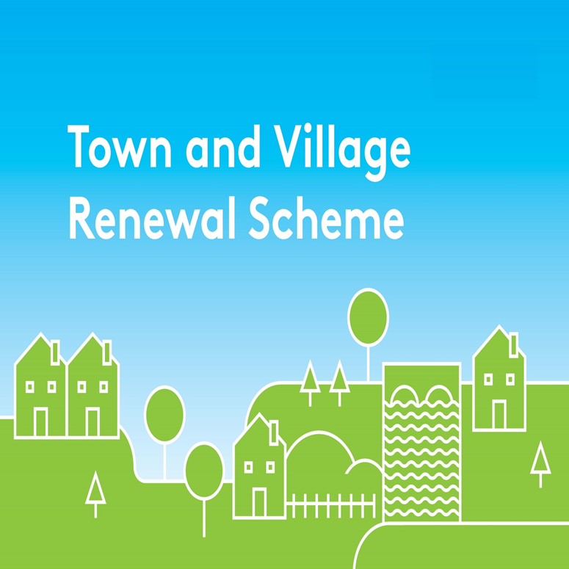
This Expression of Interest Form should be completed and returned in
word format only by e-mail to community@kerrycoco.ie by
Tuesday, 27th October, 2026.
(The deadline is set to allow all applications to be assessed in advance of the Local Authority submitting final applications to the Department of Rural and Community Development and the Gaeltacht (DRCDG) by Friday, 22nd January, 2027)

Queries should be referred to your local Municipal District Office or by email to the Community Department at community@kerrycoco.ie or by phone to 066-7183680

Please Note: Any extension of the closing date cannot be facilitated in any circumstance.

Town/Village covered:

Please indicate which category of funding is being applied for:

Category 1 Category 2 Category 3

Towns/Villages with Towns/Villages with Towns/Villages with

Population of 5,000 Population of Population up to

or less 5,001-10,000 15,000

Category 4 Pilot “Urban Towns “Category

Amount of Funding Requested:

Applicant Group:

Applicant Contact Name:

Applicant Contact Address:

Applicant Telephone Number:

Applicant Mobile Number:

Applicant Email Address:

Section 1
- Has funding for this project ever been sought from other sources? Yes No
(If "YES" yes please specify from what source and if funding was provided)

- Is this application to develop a plan to improve a town’s fabric and/or streetscape following the completion of reparation flood relief works which have been undertaken to avoid, or in response to, flooding events? Yes No

Section 2: Application Detail

Project Information
1. | Please provide a synopsis of the project proposal and the works proposed.  Include a summary of the project that will be developed as a result of the completion of the proposal:
2. | List all additional stakeholders involved in this application:
3. | Outline how the proposed final project will help to rejuvenate and enhance the town/village:
4. | Outline how the proposed final project is strategic in nature:
5. | Has this project been identified as part of a Town Centre First Plan/ Health Check/County Development Plan/LECEP or similar produced for the town or village?
6. | Outline the consultation which has taken place to date with stakeholders/beneficiaries e.g. sectoral authorities/agencies, business community, local community groups, residents etc. in relation to the proposal.  Specifically highlight any issues which arose on foot of consultation and how these have been, or are being, addressed:
7. | Is there a planning application in relation to this project in place/ in process? If so, please provide the Planning Reference Number (if applicable):
8. | Provide a timeline for commence and completion of the project:  - Commencement Date:  - Completion Date:  - Time-frame (weeks/months):
9. | Please provide the Eircode or XY (ITM format) coordinates of the project: XY coordinates should be captured in Irish Transverse Mercator (ITM) formats.  Coordinates can be converted to ITM format here: https://gnss.osi.ie/new-converter/. This data will be used to geo-map all successful projects.

Financial Information
- Please provide a detailed breakdown of all elements of the proposed project.
- All project costs must be inclusive of VAT.
- Projects supported under this measure must be must be fully completed and drawdown documentation submitted to the Department within the 12-18 month timeframe allowed for completion from project approval.
- Please add additional rows if required.
 | Project Elements | Estimated Cost (Including VAT)
1. |  | €
2. |  | €
3. |  | €
4. |  | €
 | Local Authority Costs (if applicable)
1. |  | €
2. |  | €
Total Project Cost |  | €
 | Grant Aid:  [Maximum of 90% of total project costs] | €
 | Match Funding: (Min 10% of total cost): | €
 | Supplier of Match Funding
 | Any other relevant information: Click or tap here to enter text.

DECLARATION
I hereby confirm that I have read and understand this document. I request that consideration be given in support of the project as outlined above.

Signature __________________________________________________

Position __________________________________________________

Date __________________________________________________

Kerry County Council’s Community Department reserves the right to publish a list of all grants awarded on its website www.kerrycoco.ie.

All personal data collected is in compliance with the requirements of the General Data Protection Regulation (GDPR) 2016 and Data Protection Acts 1988 to 2003. Individual privacy notices for each section/service are available at www.kerrycoco.ie.

